First we launch instance.

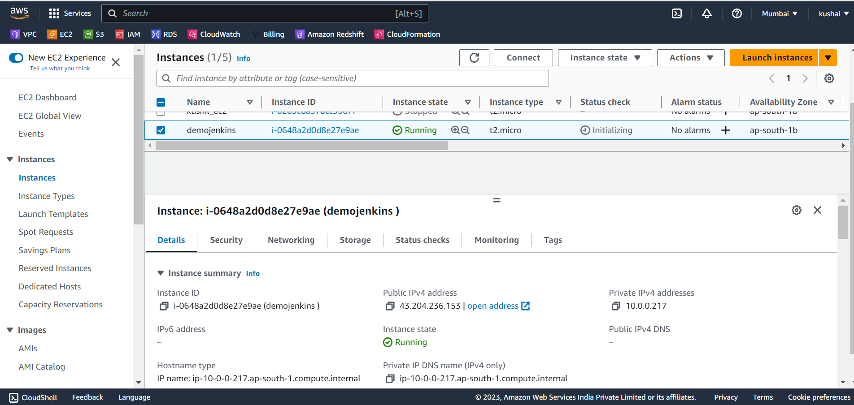

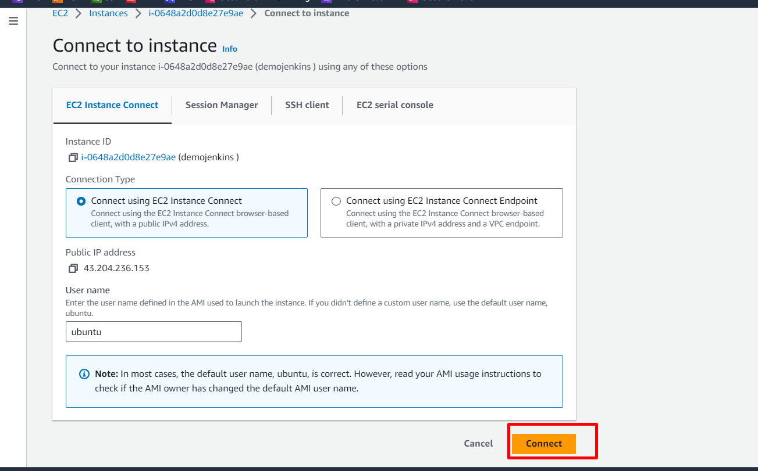

Launch instance successfully.

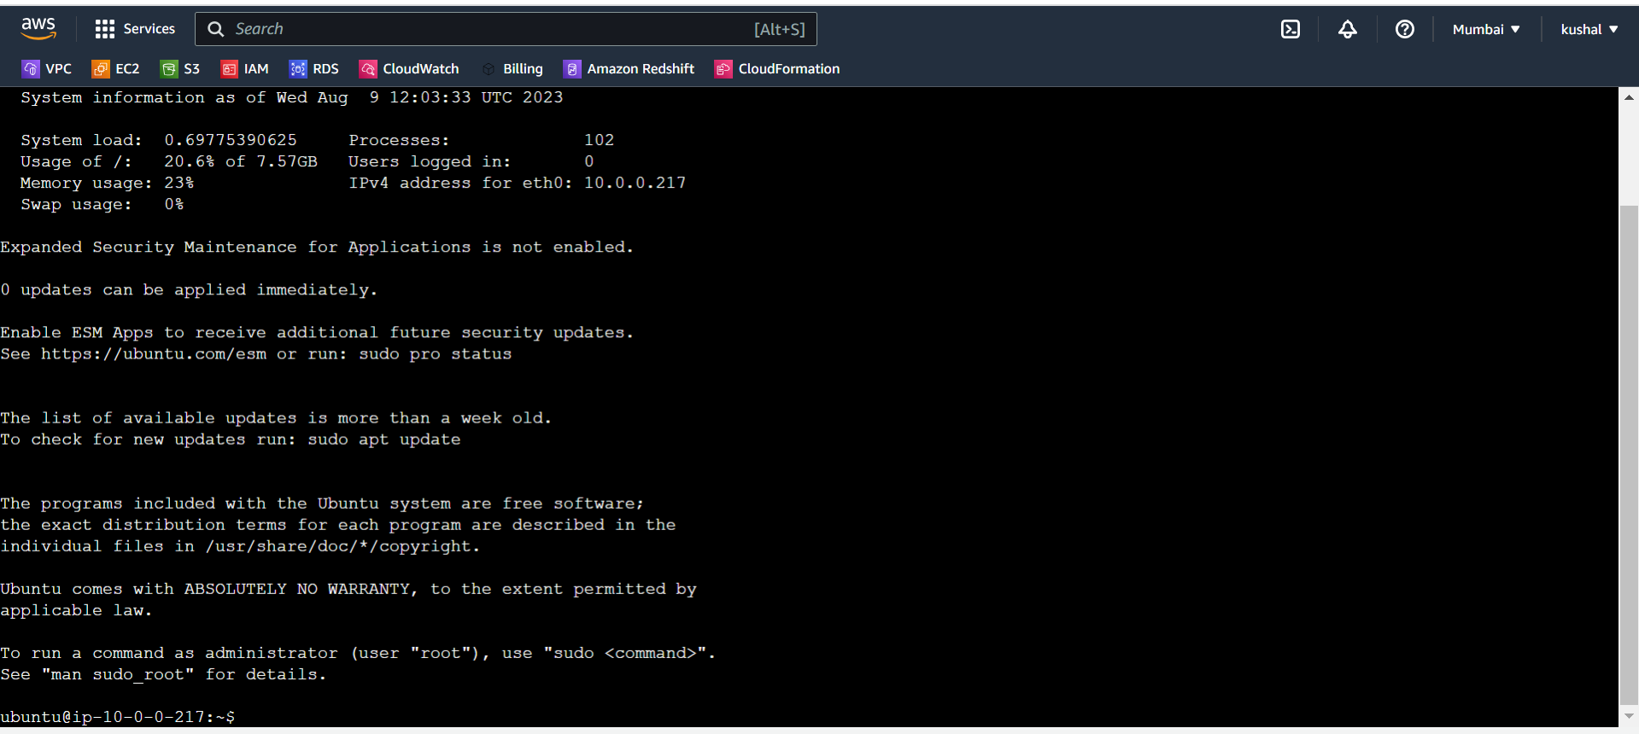

**Next we install java in that server for using this commands**

$ sudo apt-get update

$ sudo apt search openjdk #search for available packages

$ sudo apt install openjdk-11-jdk -y # Install java

$ java --version

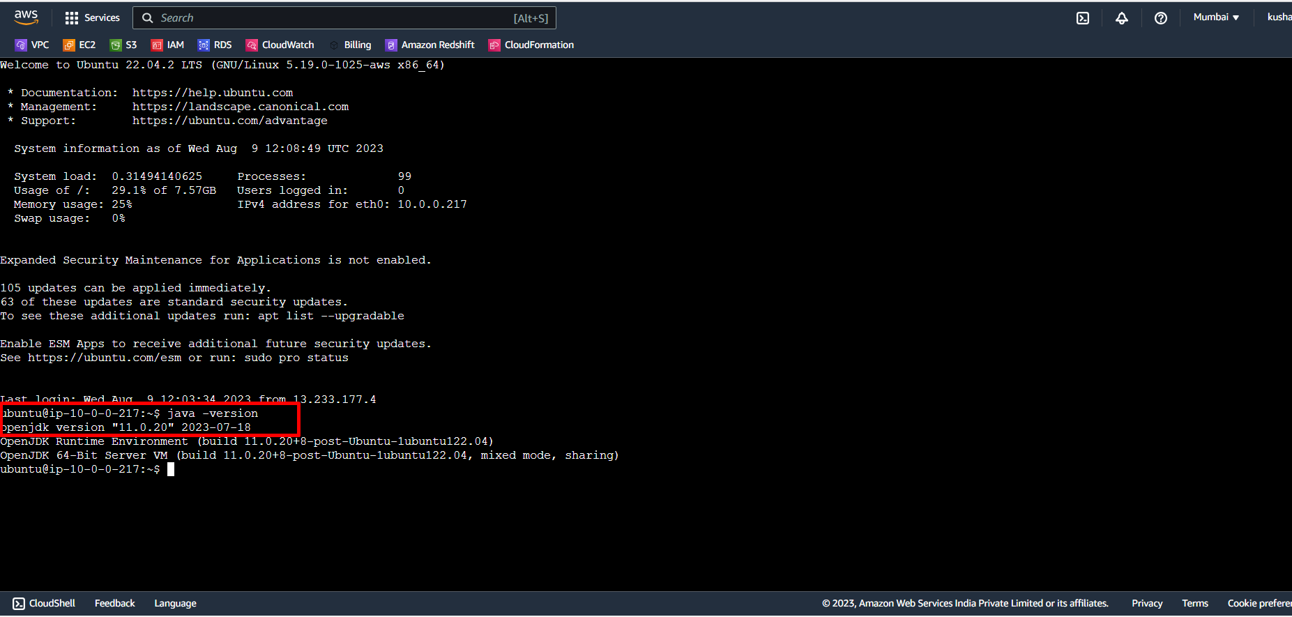

Next we install Jenkins in this server using this commands

$ wget -q -O - https://pkg.Jenkins.io/debian-stable/Jenkins.io.key | sudo apt-key add -

$ sudo sh -c 'echo deb http://pkg.Jenkins.io/debian-stable binary/ > /etc/apt/sources.list.d/Jenkins.list'

$ sudo apt-get update

$ sudo apt install Jenkins -y

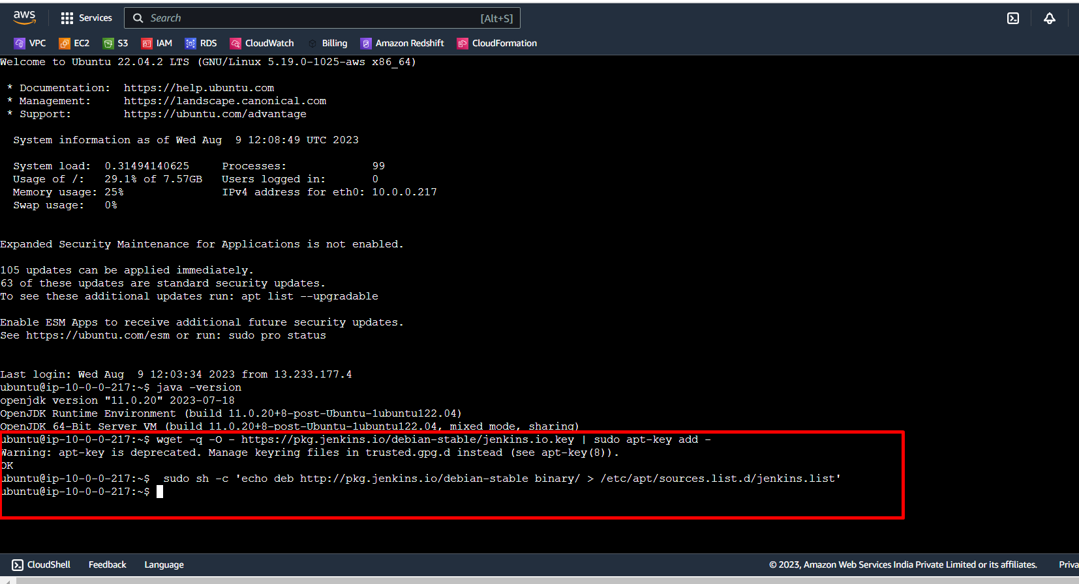

**But here I had some issue on that packages so install using different packages**

curl -fsSL https://pkg.Jenkins.io/debian-stable/Jenkins.io-2023.key | sudo tee \

/usr/share/keyrings/jenkins-keyring.asc > /dev/null

echo deb [signed-by=/usr/share/keyrings/jenkins-keyring.asc] \

https://pkg.Jenkins.io/debian-stable binary/ | sudo tee \

/etc/apt/sources.list.d/Jenkins.list > /dev/null

sudo apt-get update

sudo apt-get install fontconfig openjdk-11-jre

sudo apt-get install Jenkins

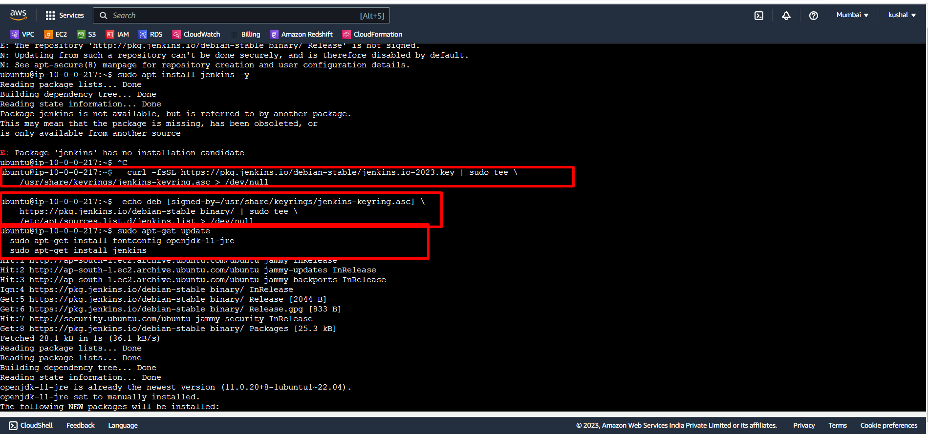

**We successfully installed Jenkins in this server.**

Next start Jenkins using “ sudo systemctl start Jenkins” this command.

Next check status Jenkins “sudo systemctl status Jenkins” this command.

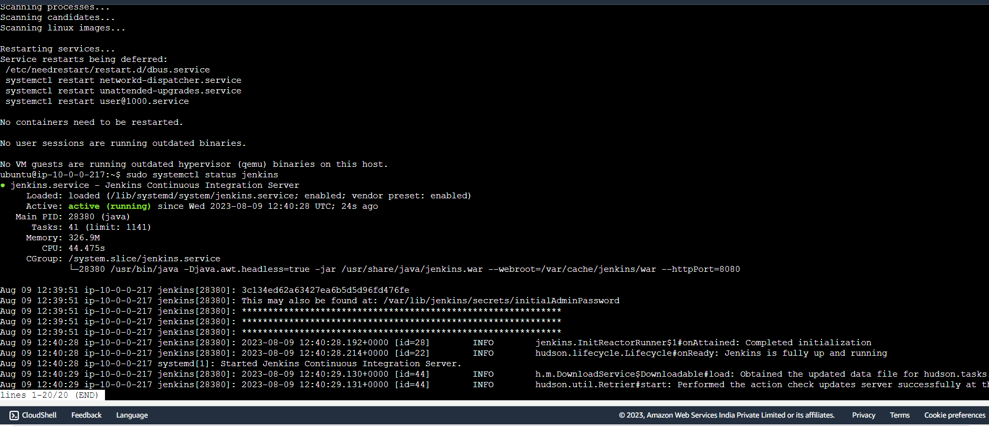

Next we copy the password using “sudo cat /var/lib/Jenkins/secrets/initialAdminPassword” this command.

Next copy the password.

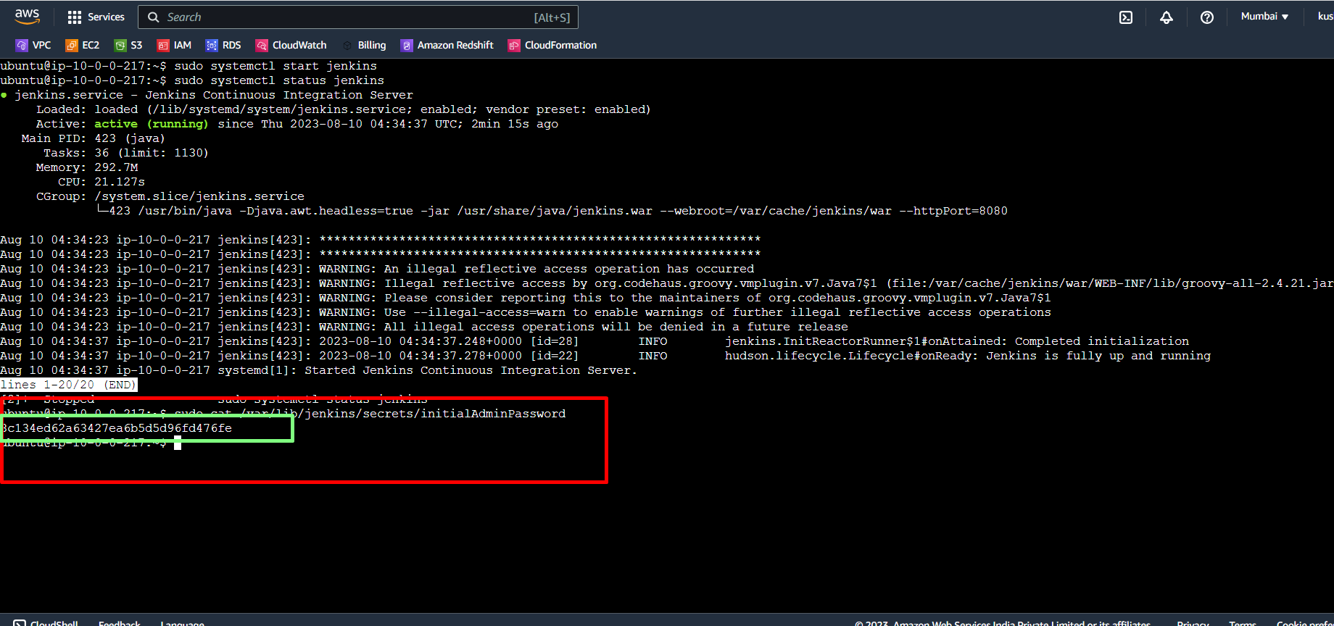

Next we take public IP of this server.

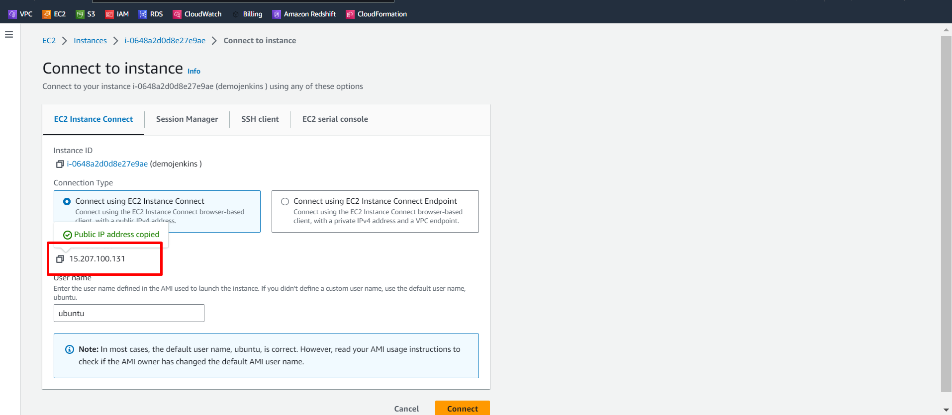

Enter public IP in this web browser with :8080 is this Jenkins default port.

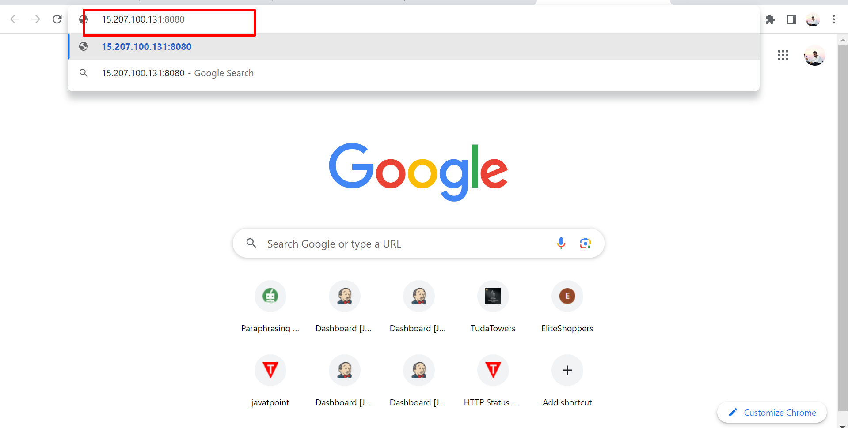

It shows errors because we do not allow this 8080 port in this server , then we allow this port 8080 in this server now.

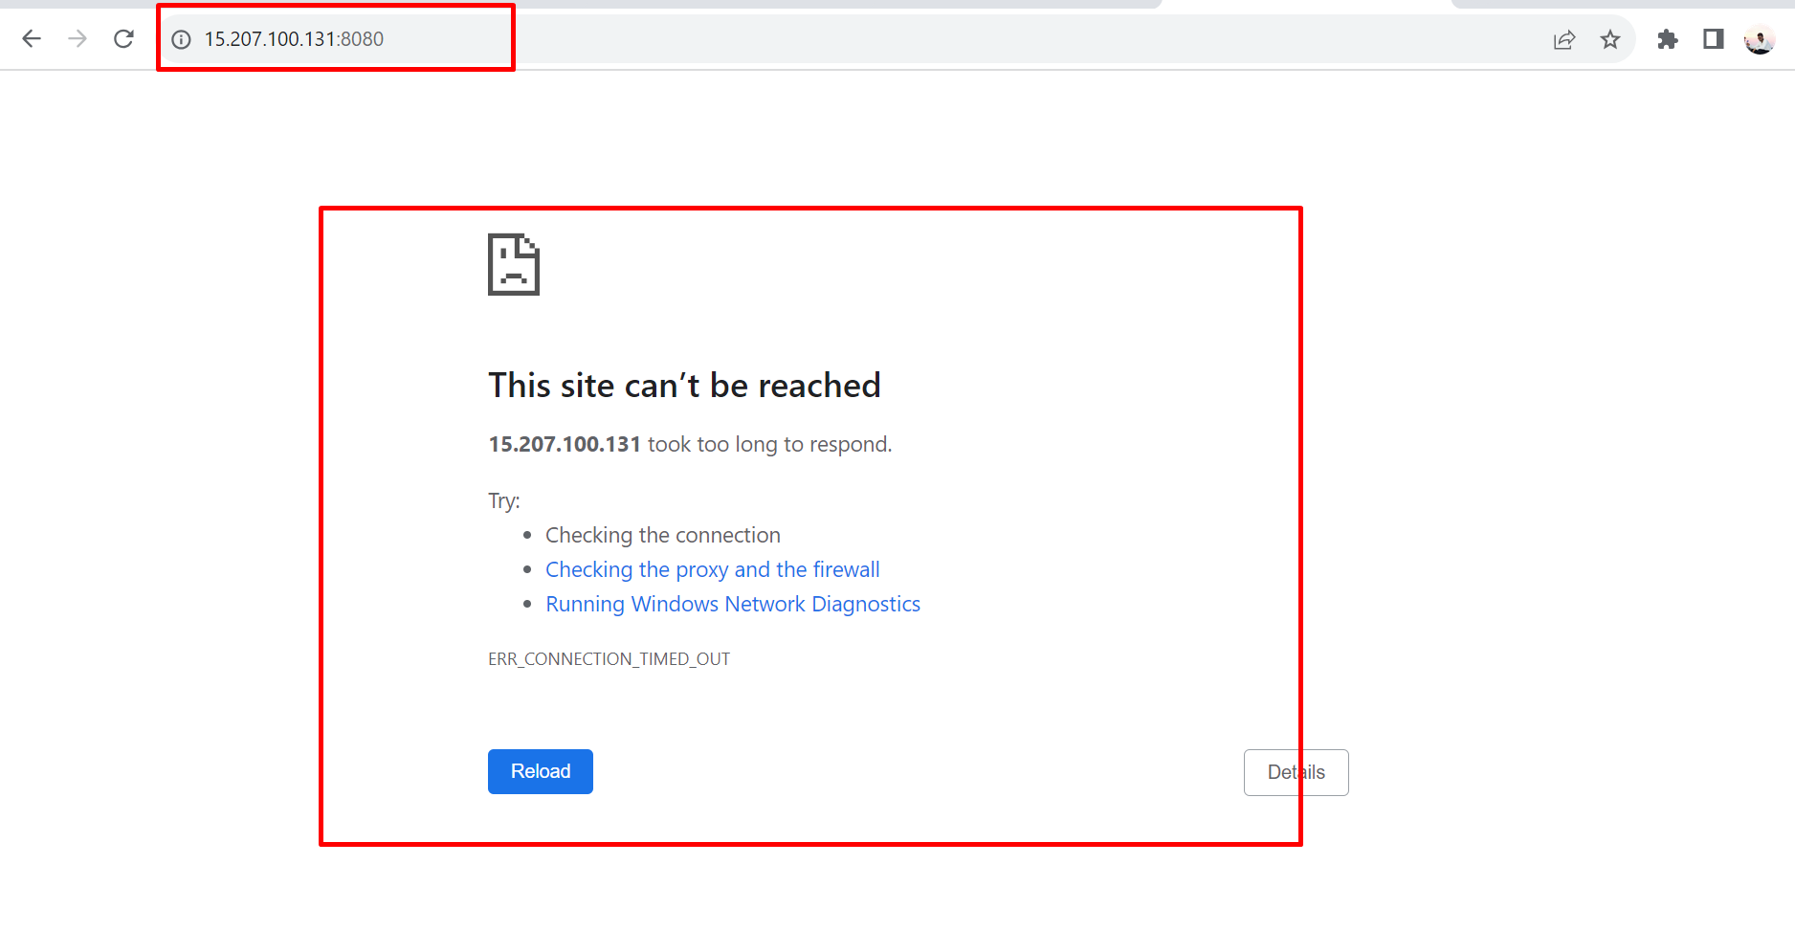

Go to EC2 - security group-edit inbound rules to add rule with port 8080 and source 0.0.0.0/0

Next we save this rule.

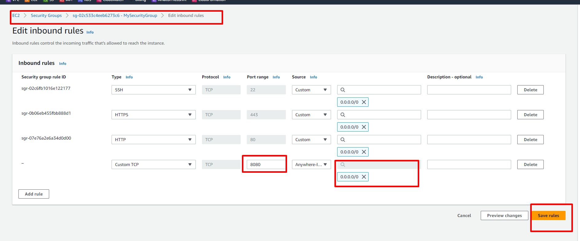

We add new rule successfully.

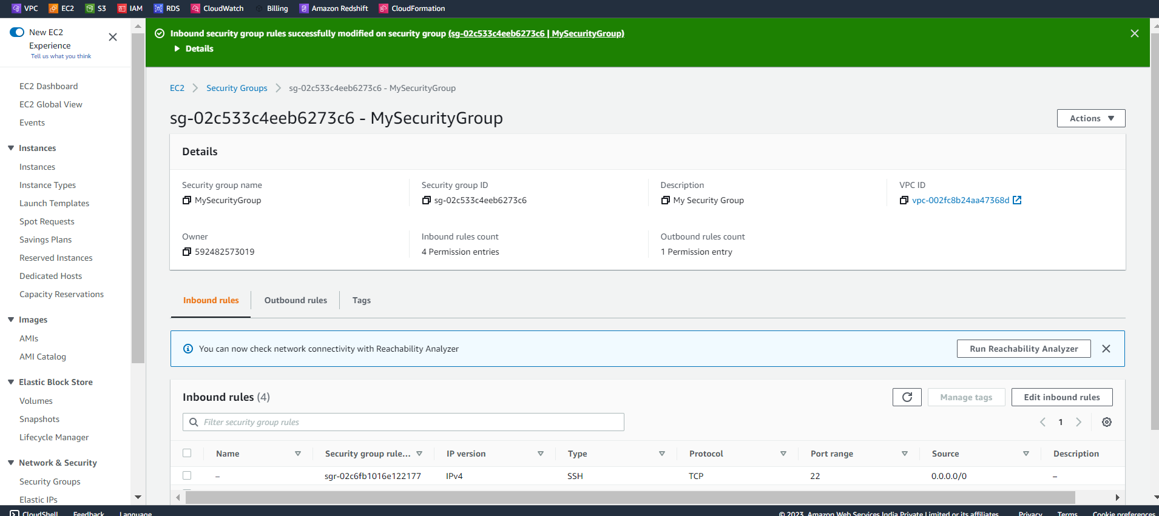

Here we paste the password using ‘’sudo cat /var/lib/Jenkins/secrets/initialAdminPassword” this command in the server,copy the password and paste here.

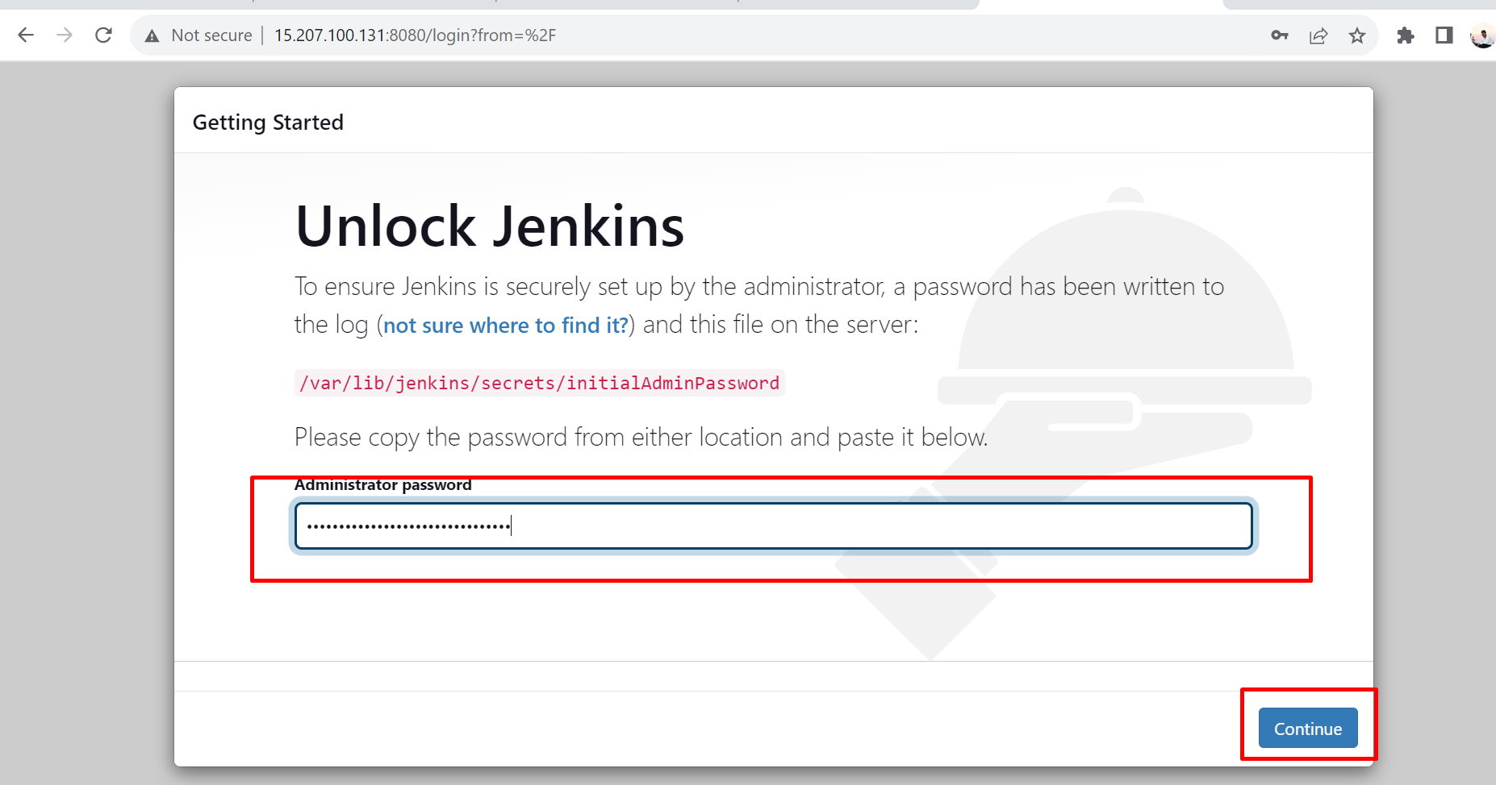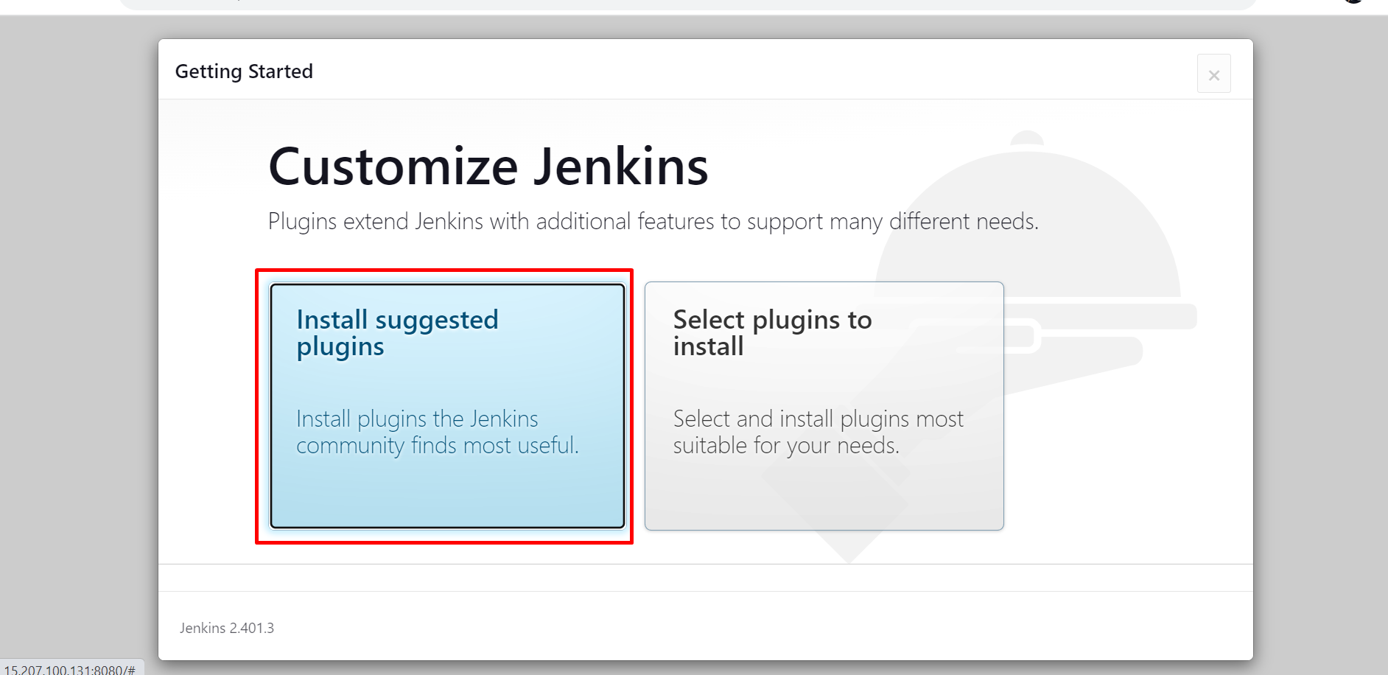

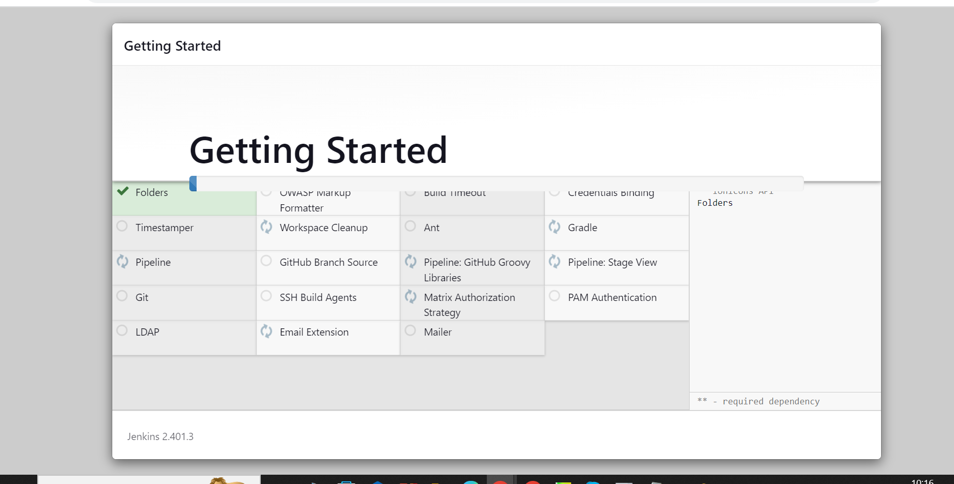

Next we create a user with password for login Jenkins.

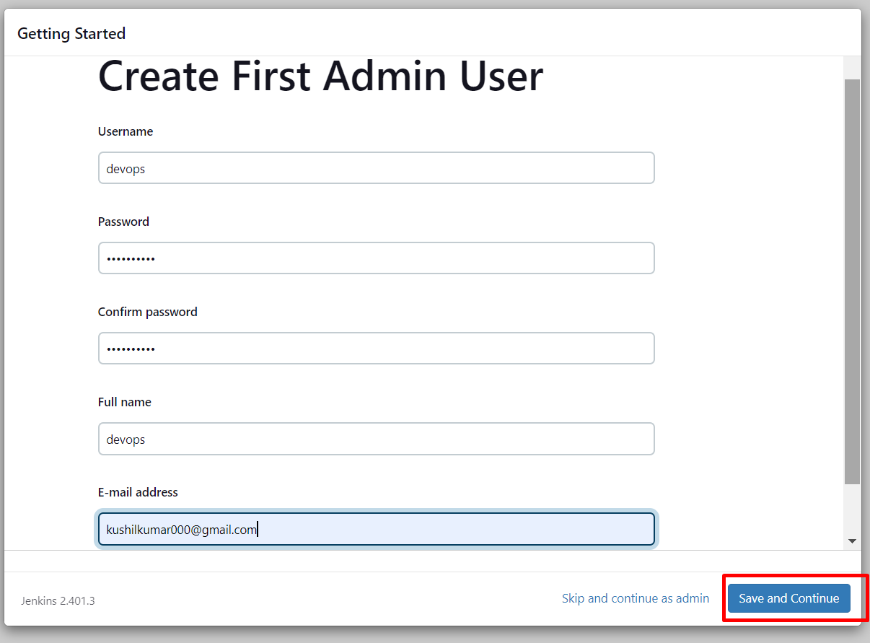

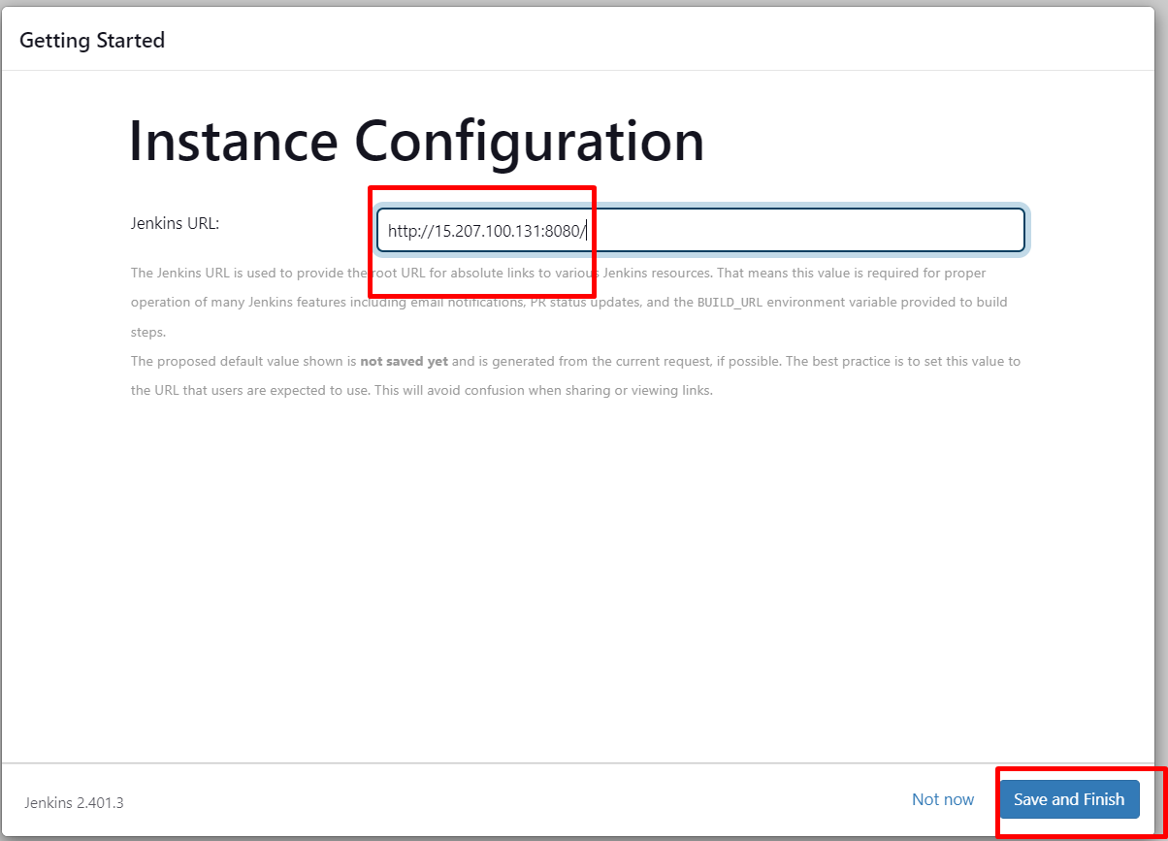

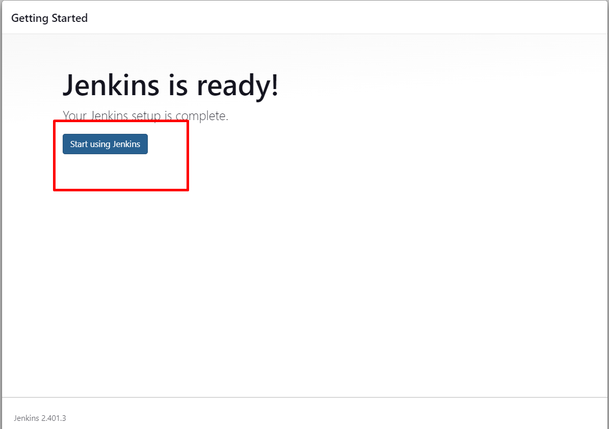

We successfully login Jenkins.

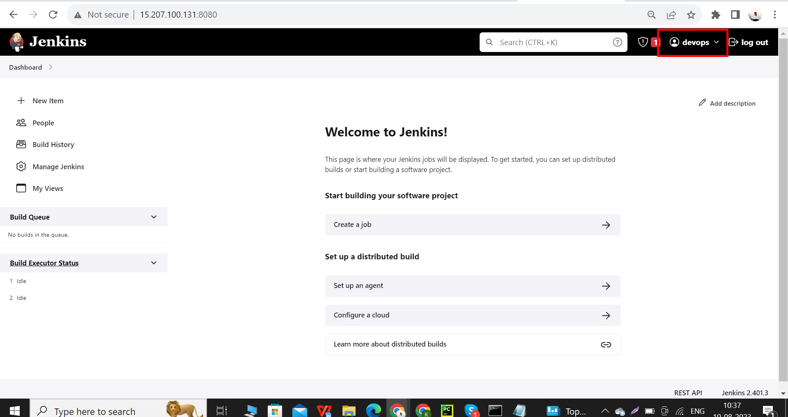

This is my GitHub now I want to deploy this files into Ubuntu server

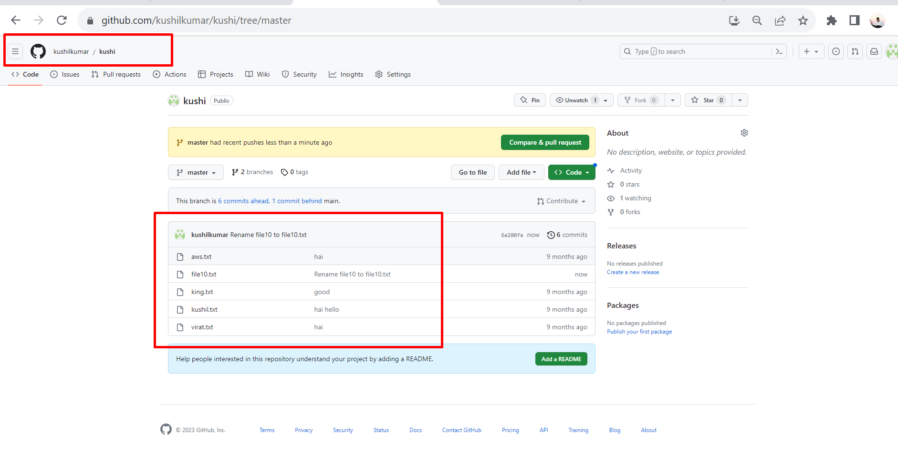

We install apache2 in this server using this commands

1. sudo apt update
2. Sudo apt install apache2 -y

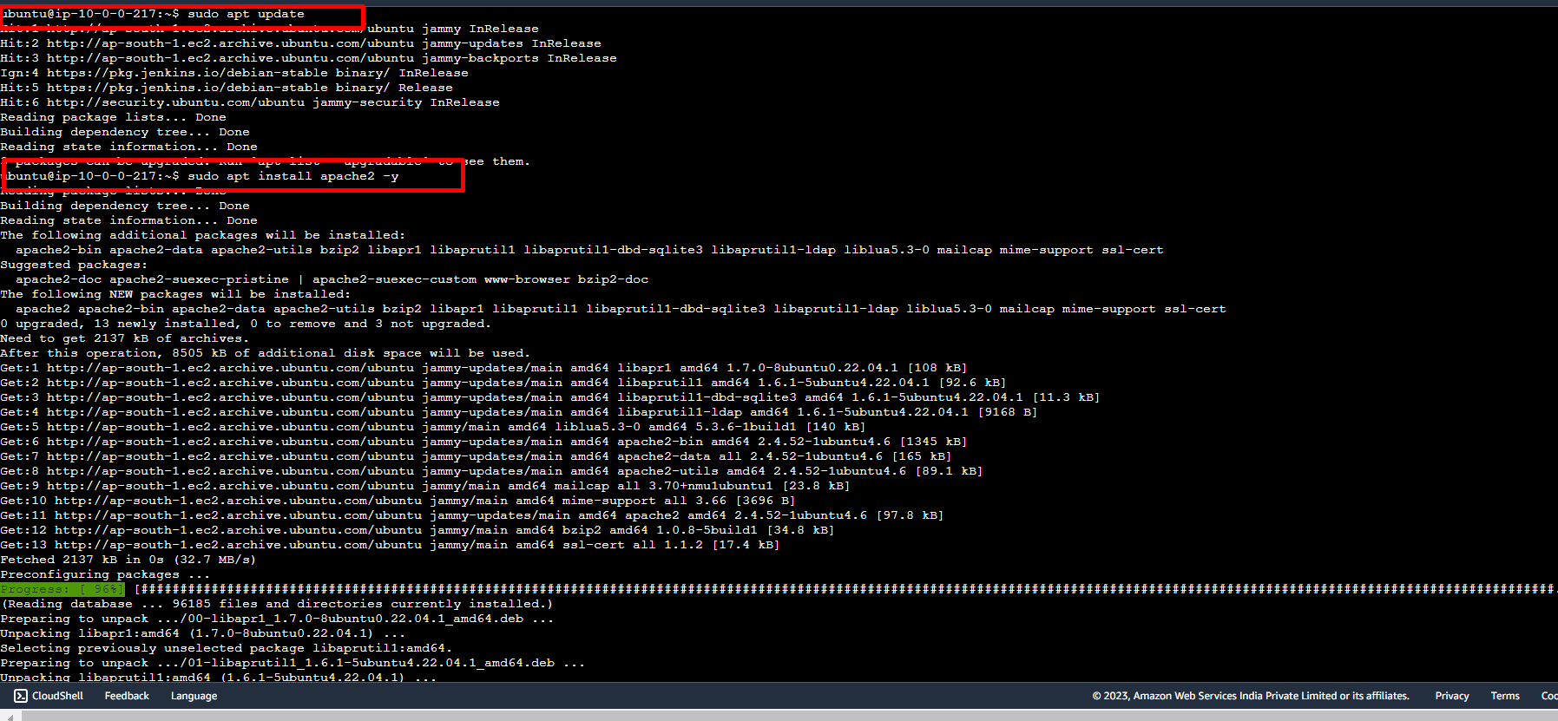

We start service - sudo systemctl start apache2

We check status of apache2 - sudo systemctl status apache2

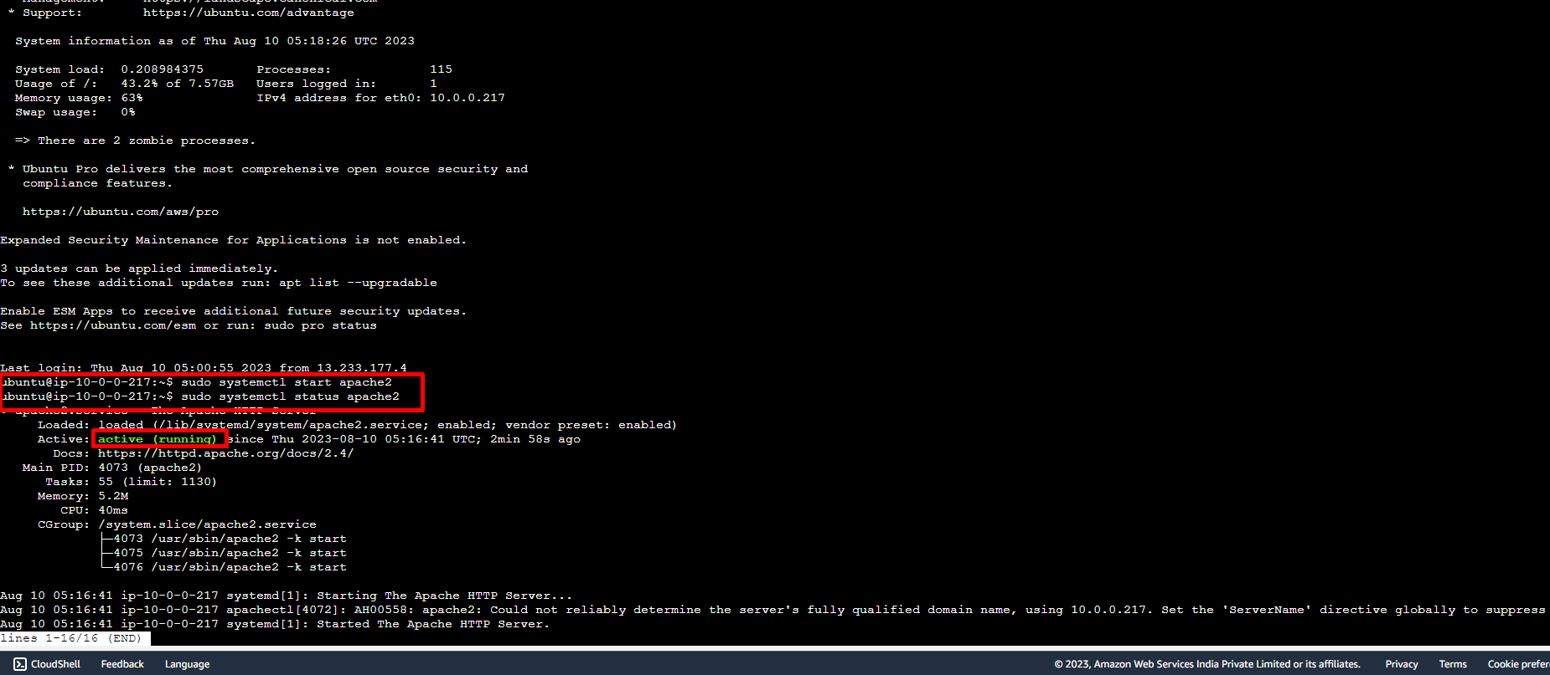

Next we check the apache2 is working.

Copy public IP and paste in web browser it shows like this.

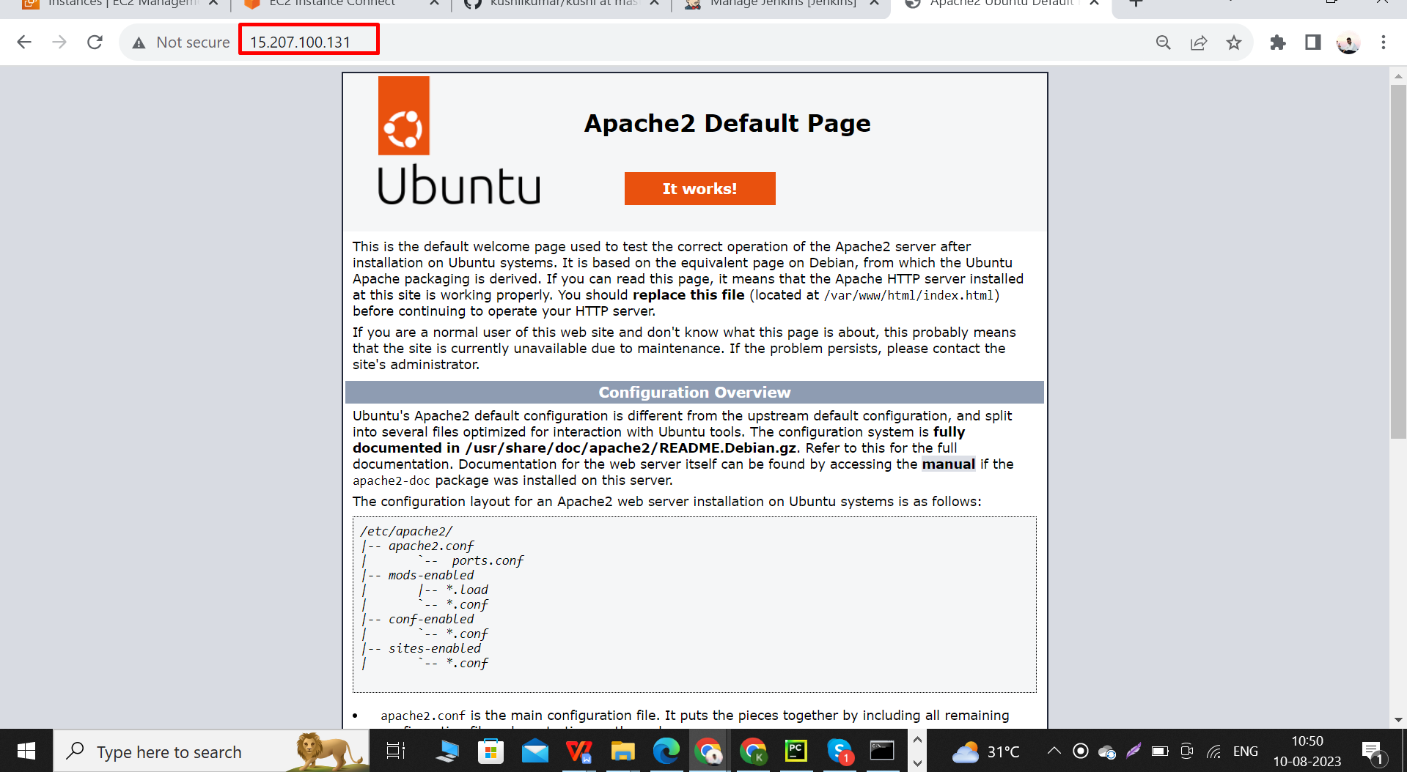

Next we go to Jenkins.

In this go to manage Jenkins - next go to plugins.

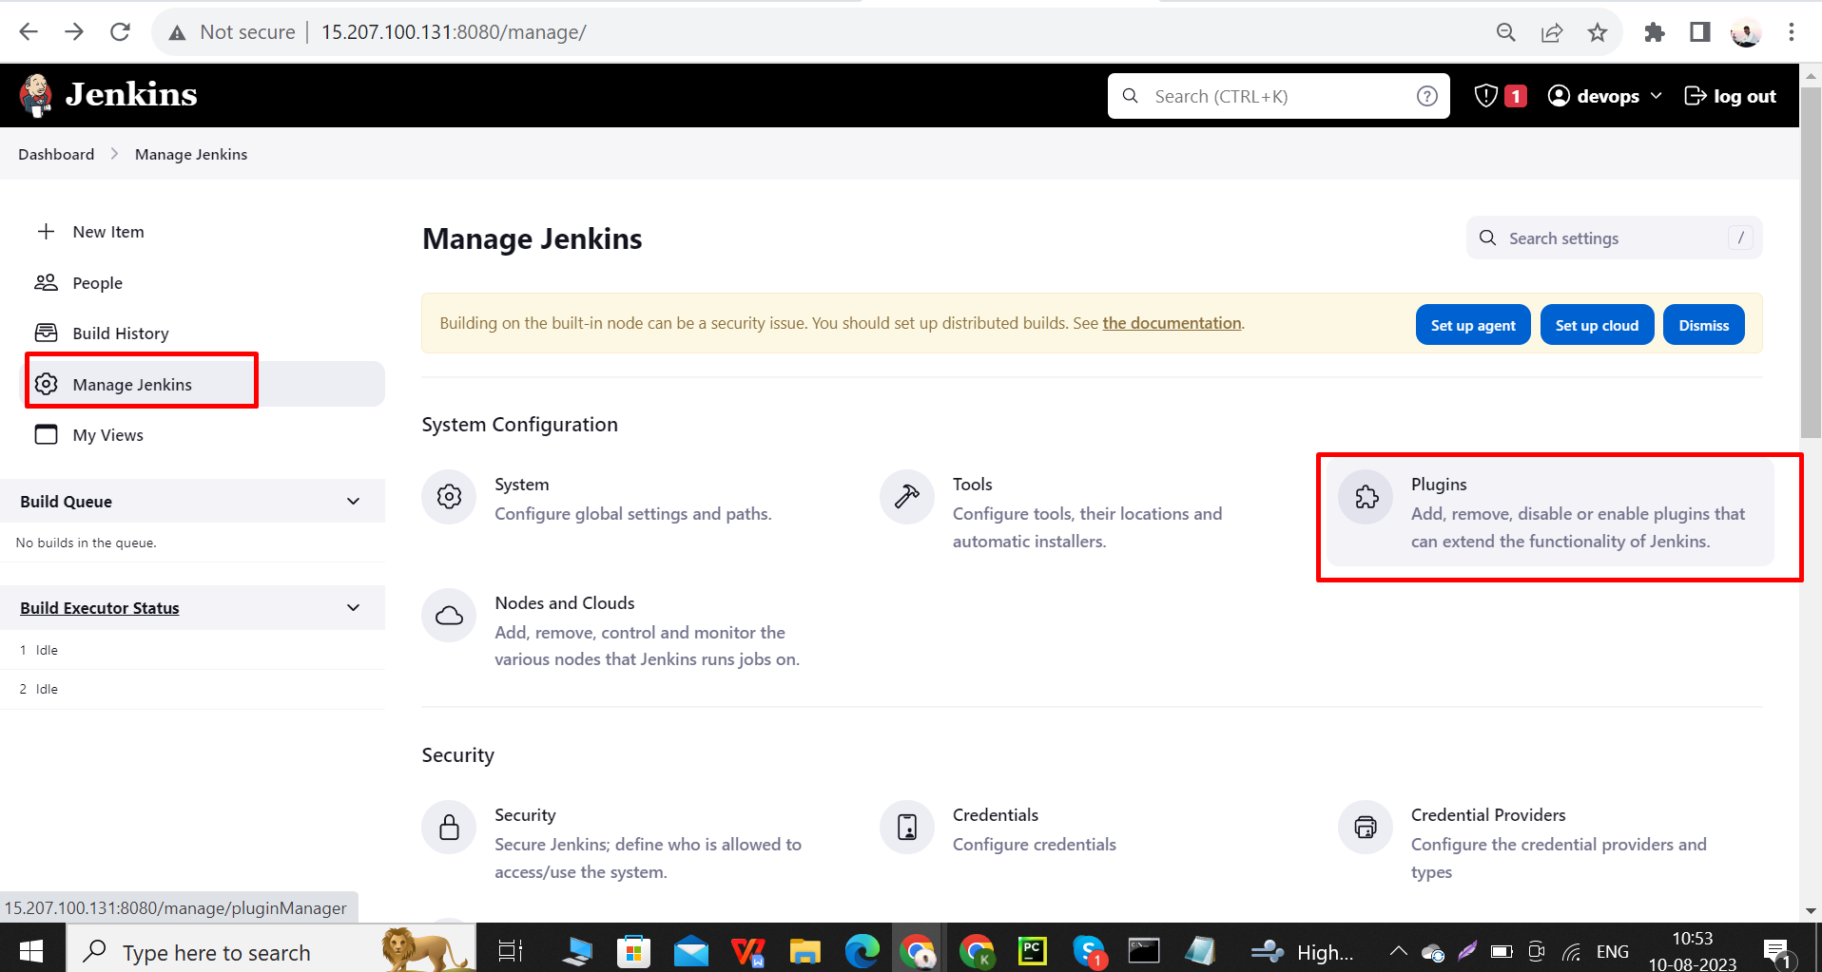

Next click on **available plugins** and in search bar search **publish over ssh** and **allow that** and click i**nstall without restart**

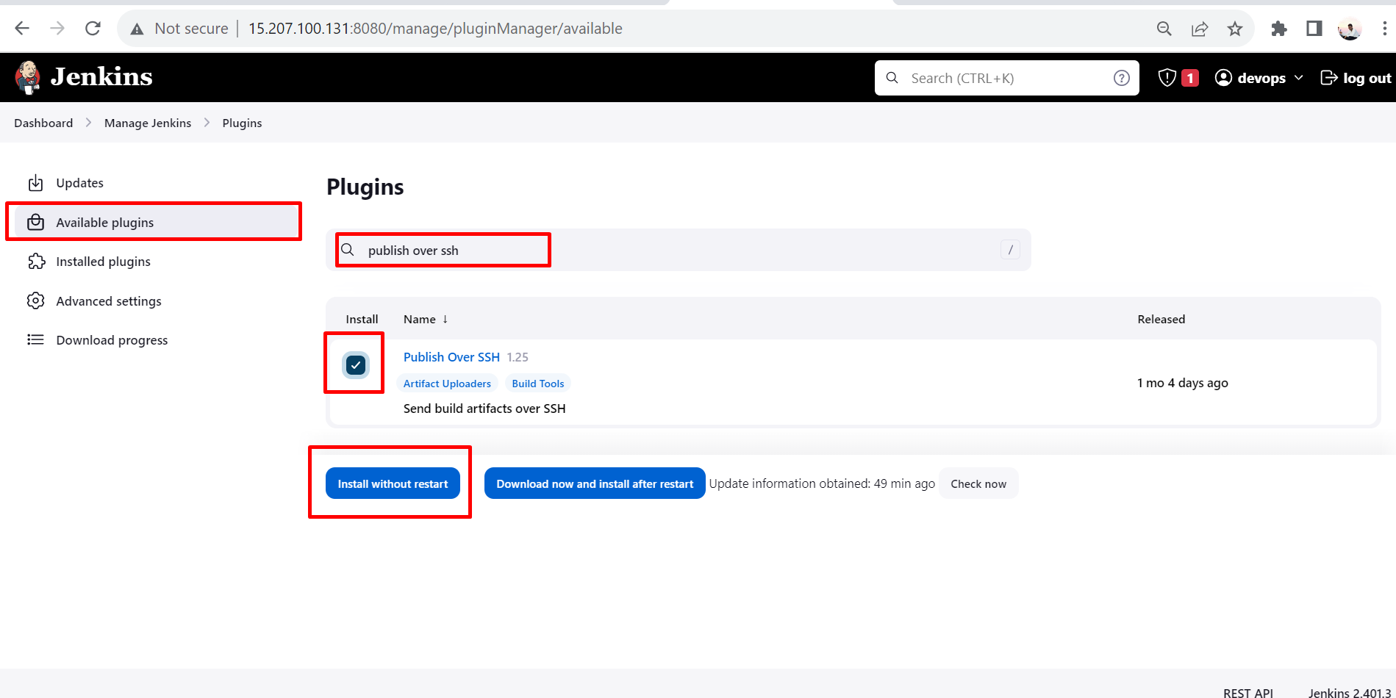

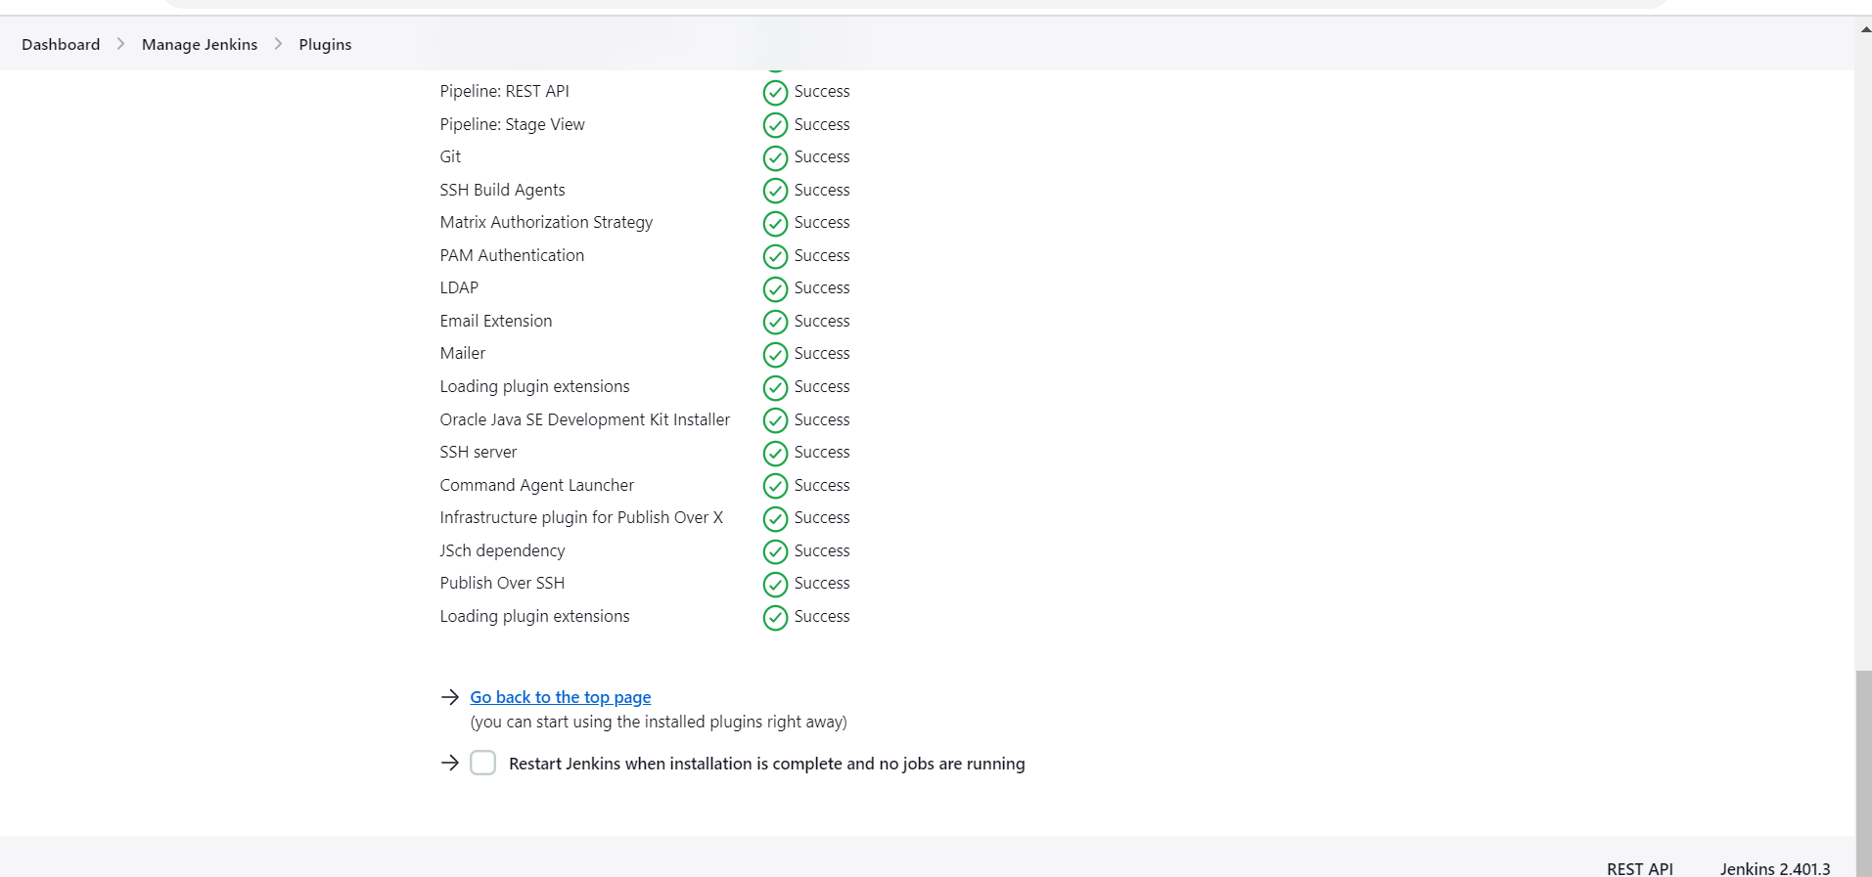

After installing plugins, go to manage Jenkins -go to system .

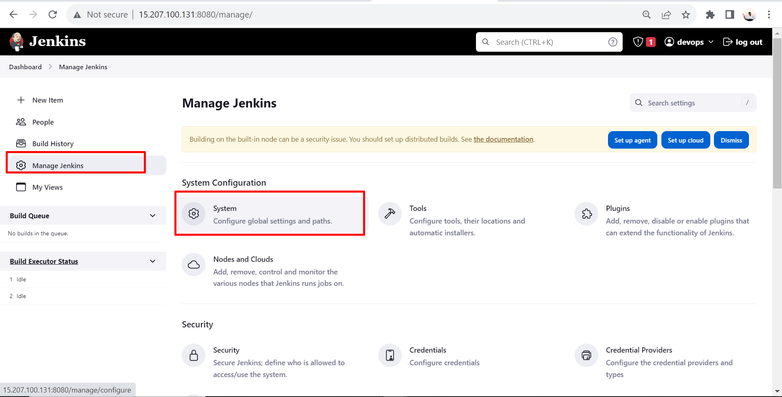

Scroll down in that system and go to publish over SSH.

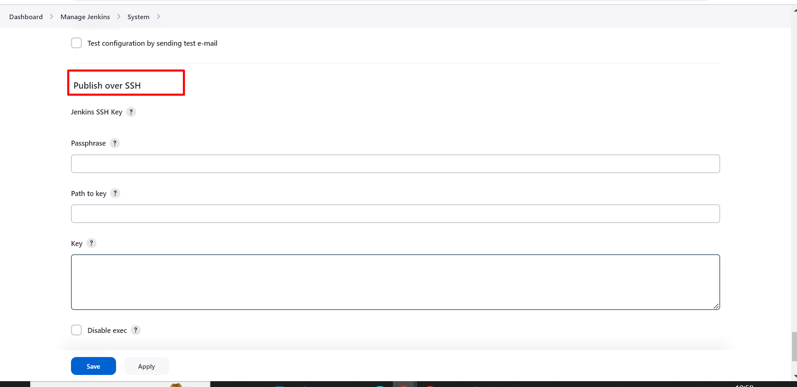

Copy private pem key, which pem key we assign to this ec2.

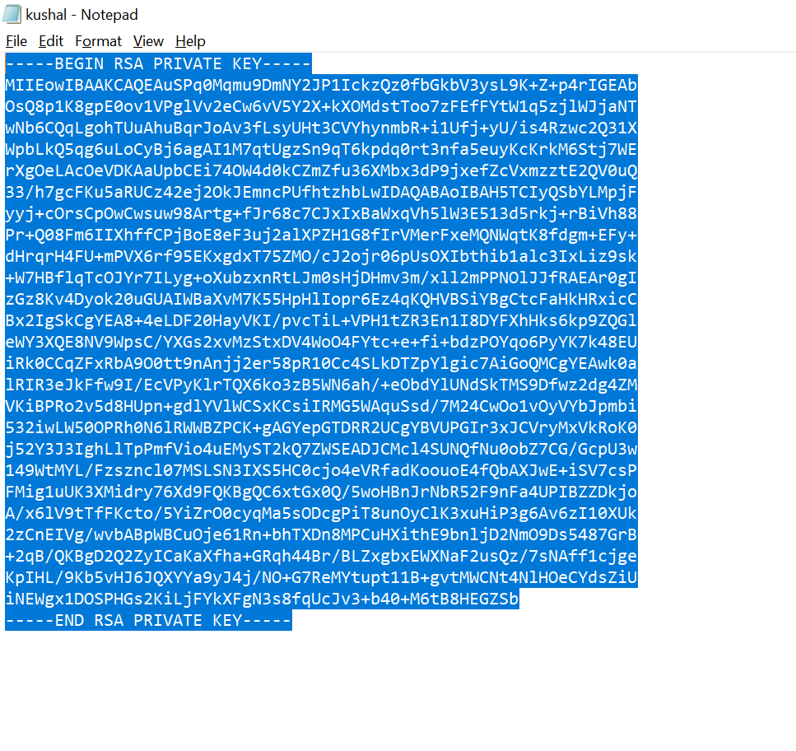

Next paste that pem key in key in publish over SSH.

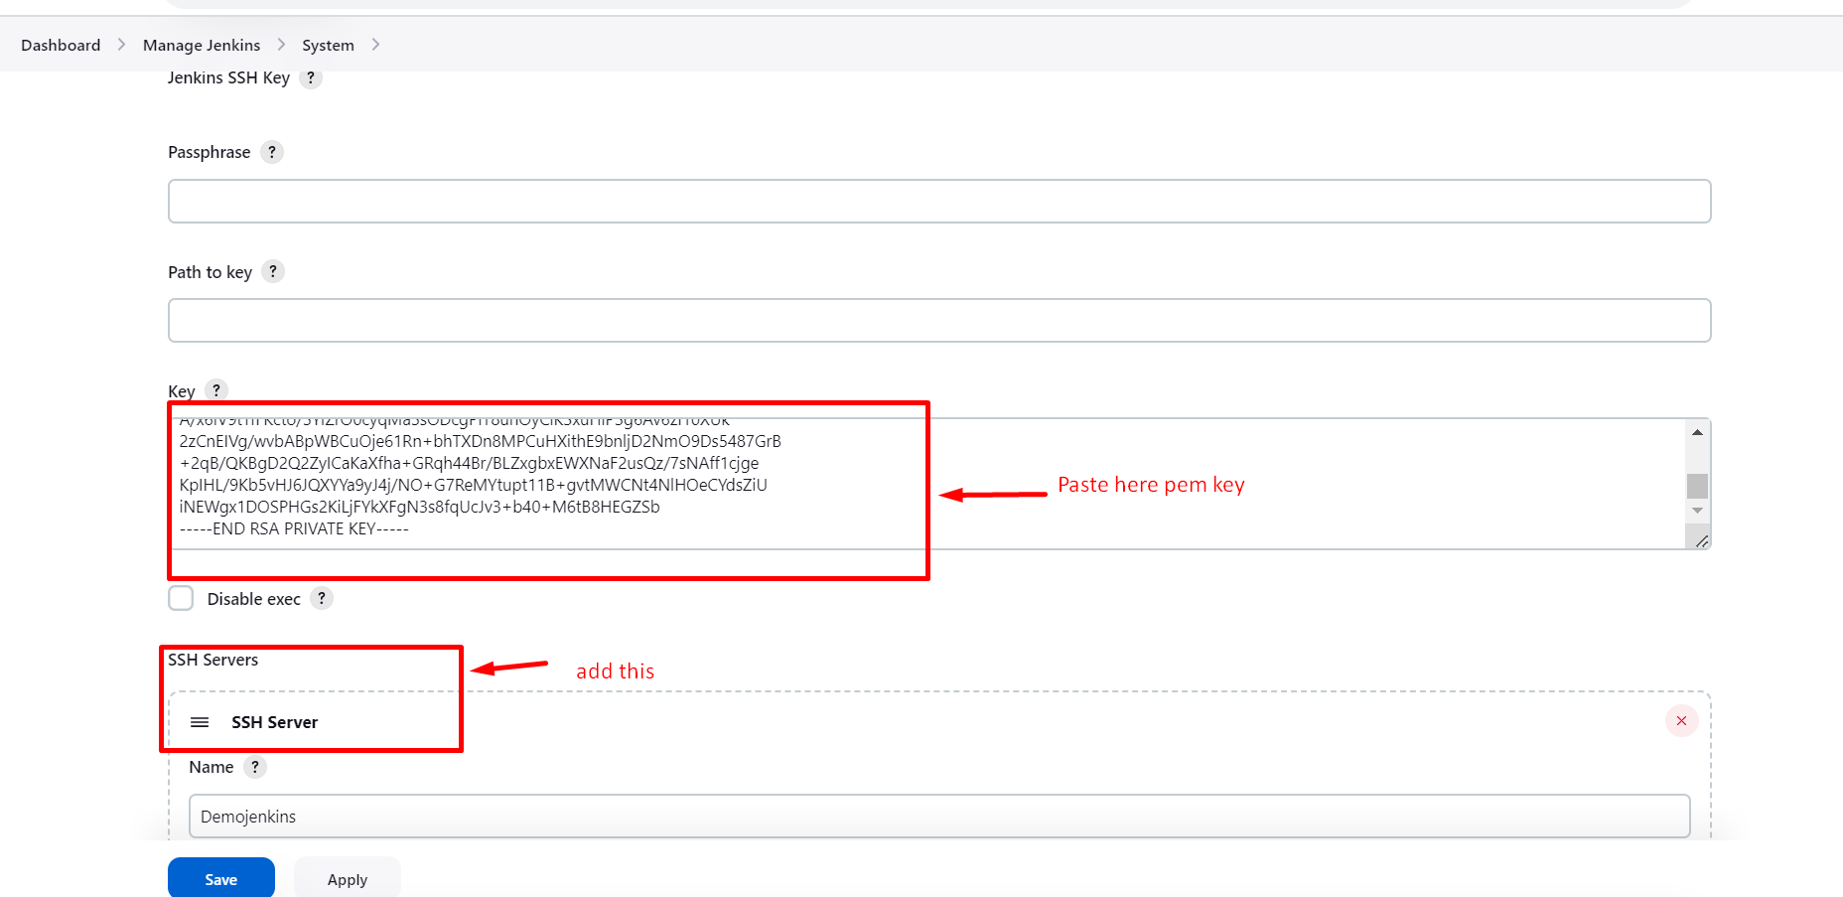

Enter the necessary requirement and click on test configuration and when we get the success then click on save.

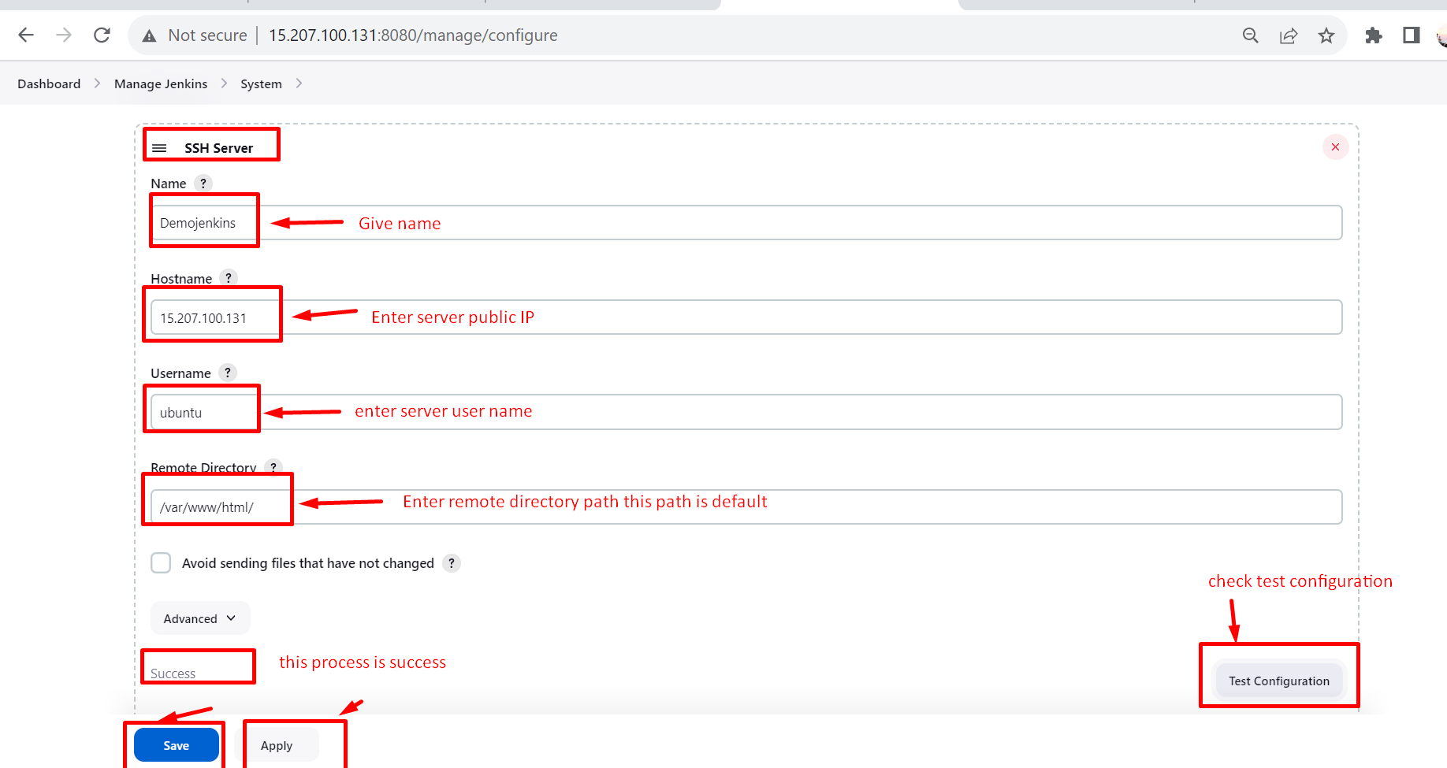

Before we create a project first check git is installed or not if in case not installed

Use “sudo apt install git -y “ this command in server.

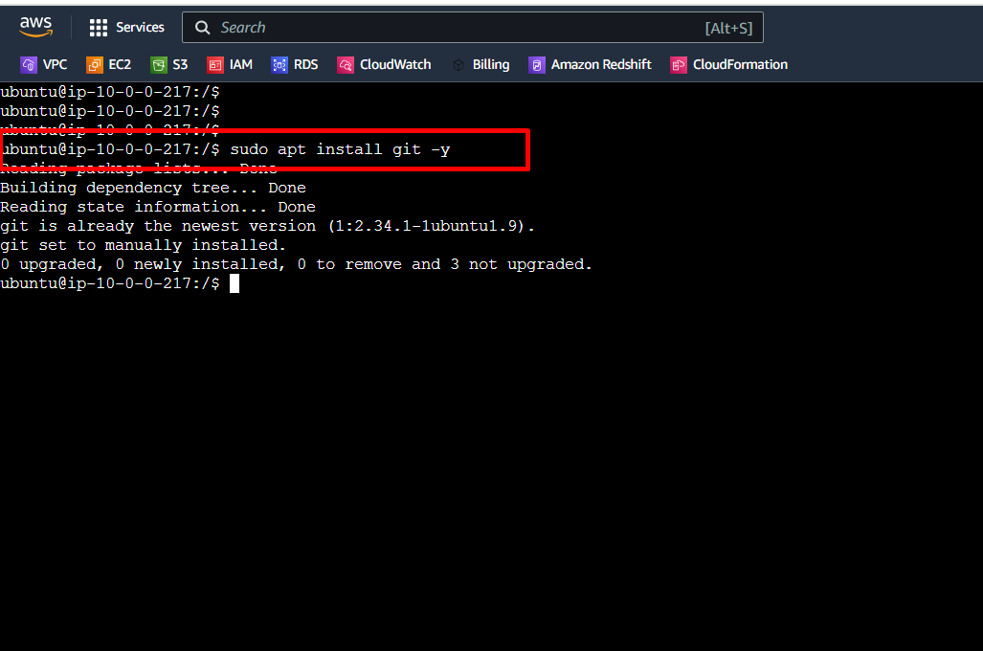

After that we create a freestyle project.follow bellow process.

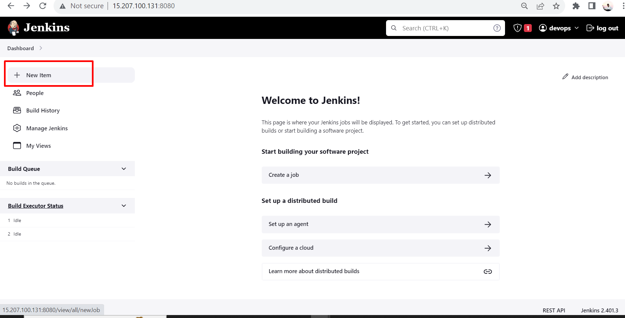

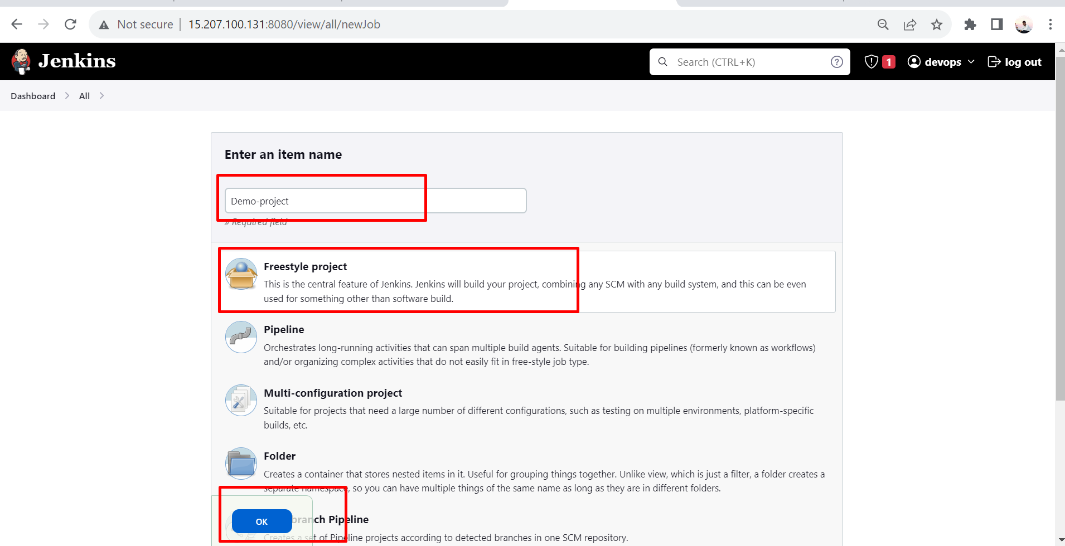

Copy GitHub url .

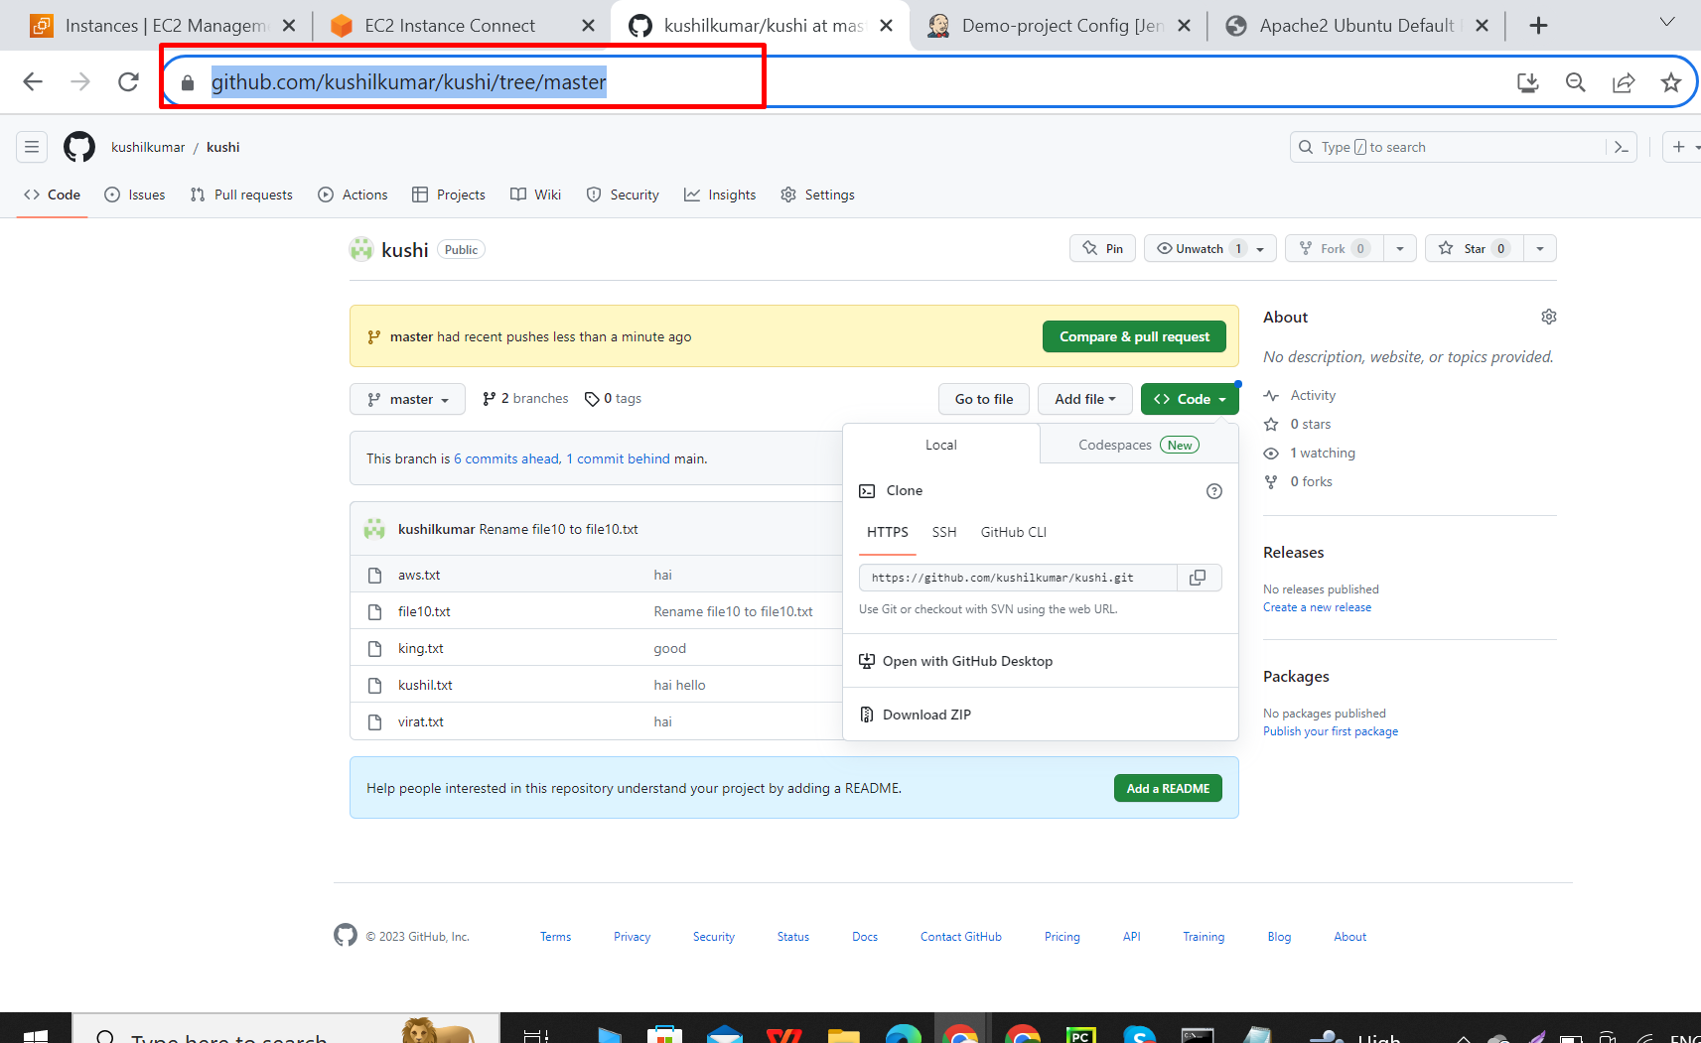

In configure go to general - select GitHub project and paste the git url here.

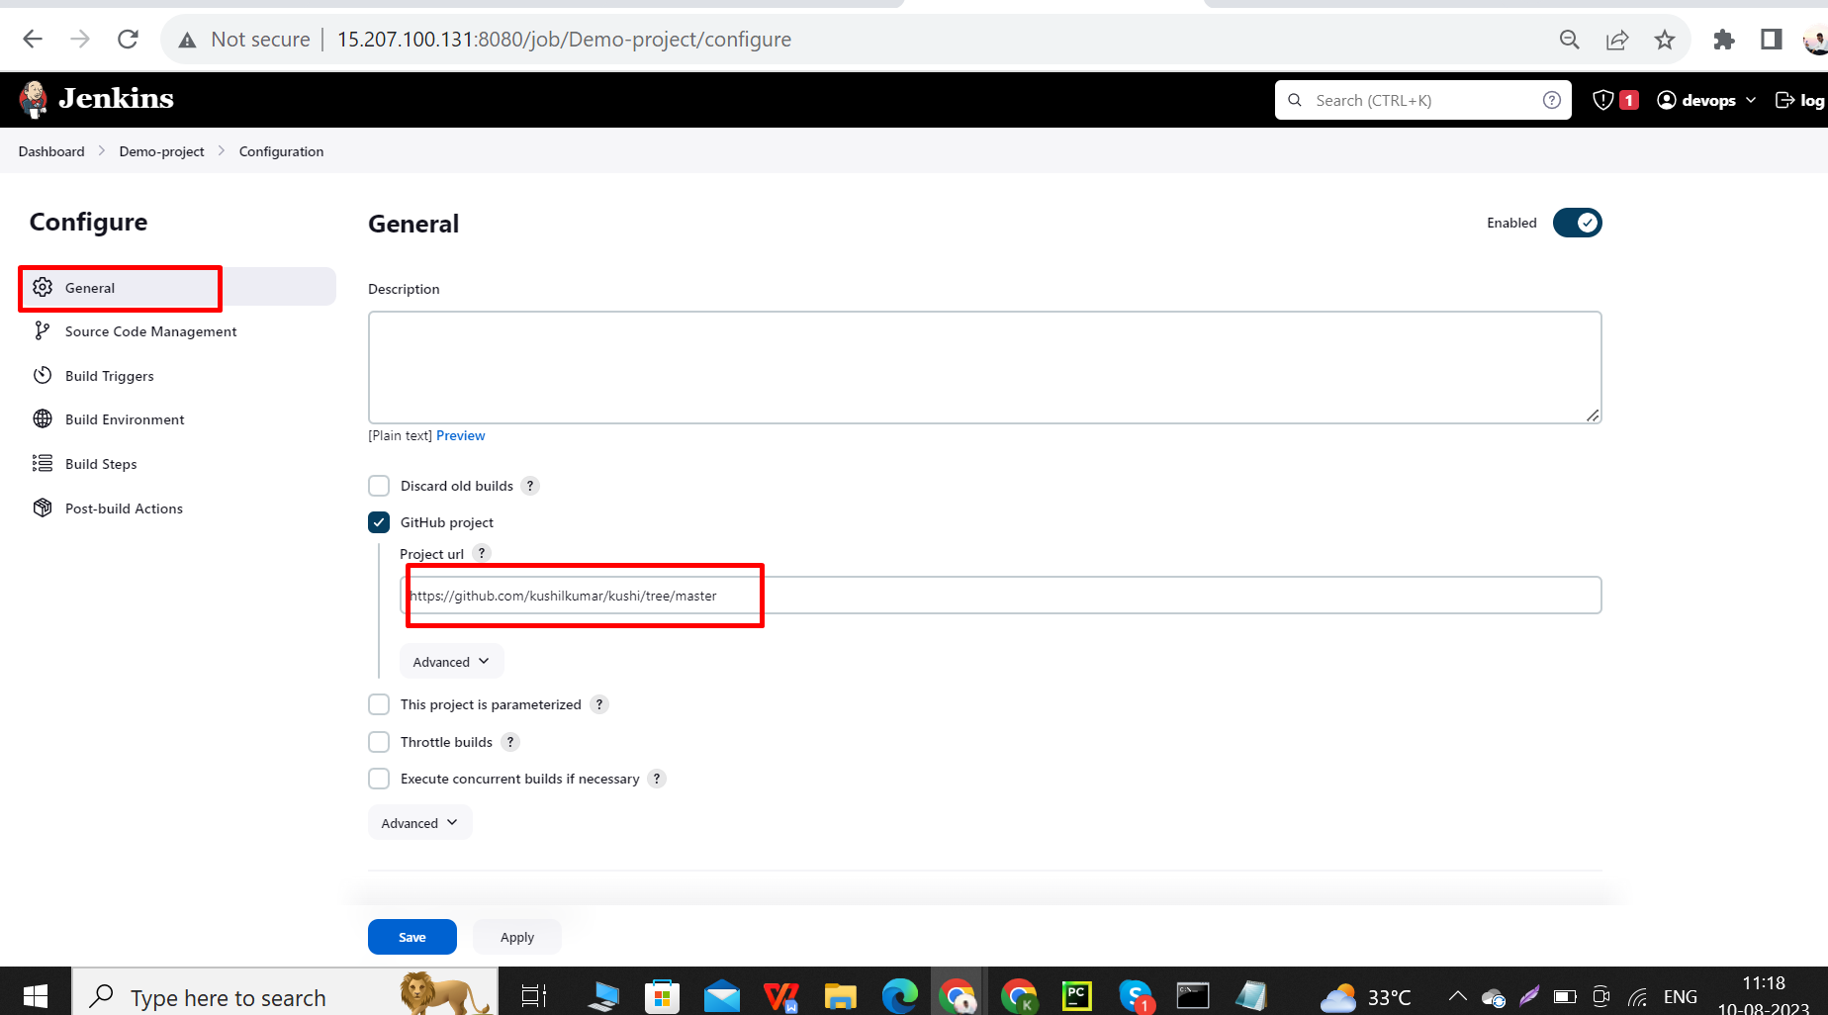

Next copy GitHub repository url path .

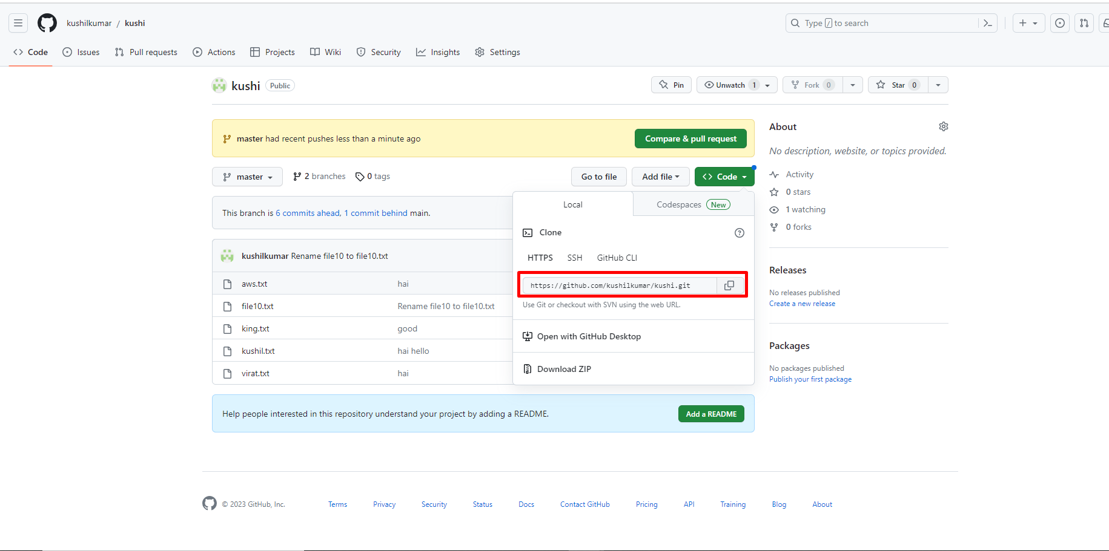

Select **Git** in source code management and paste that url and also check the branch master or main for our requirement.

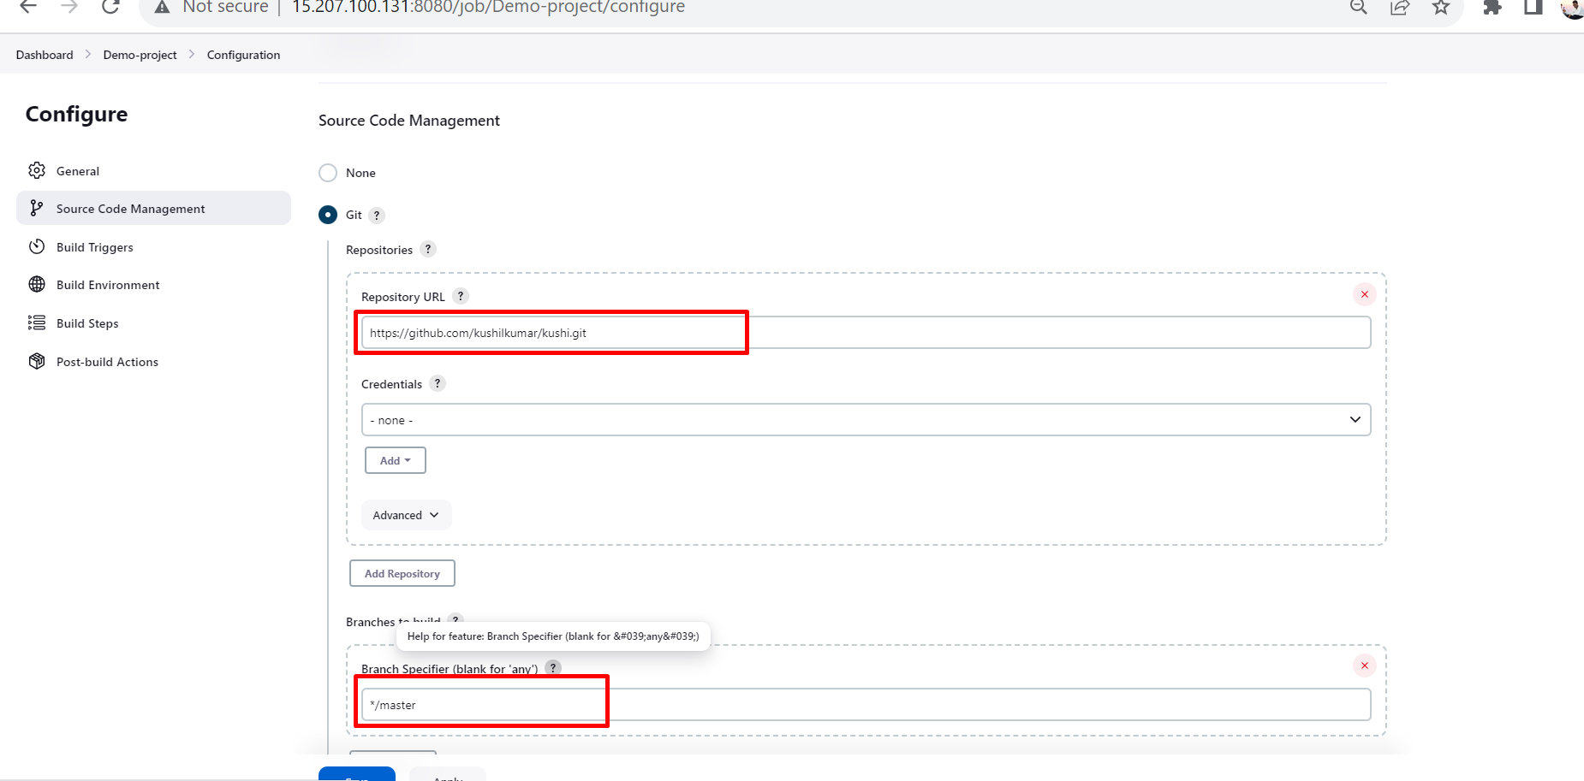

Next select GitHub hook trigger for GITScm polling.

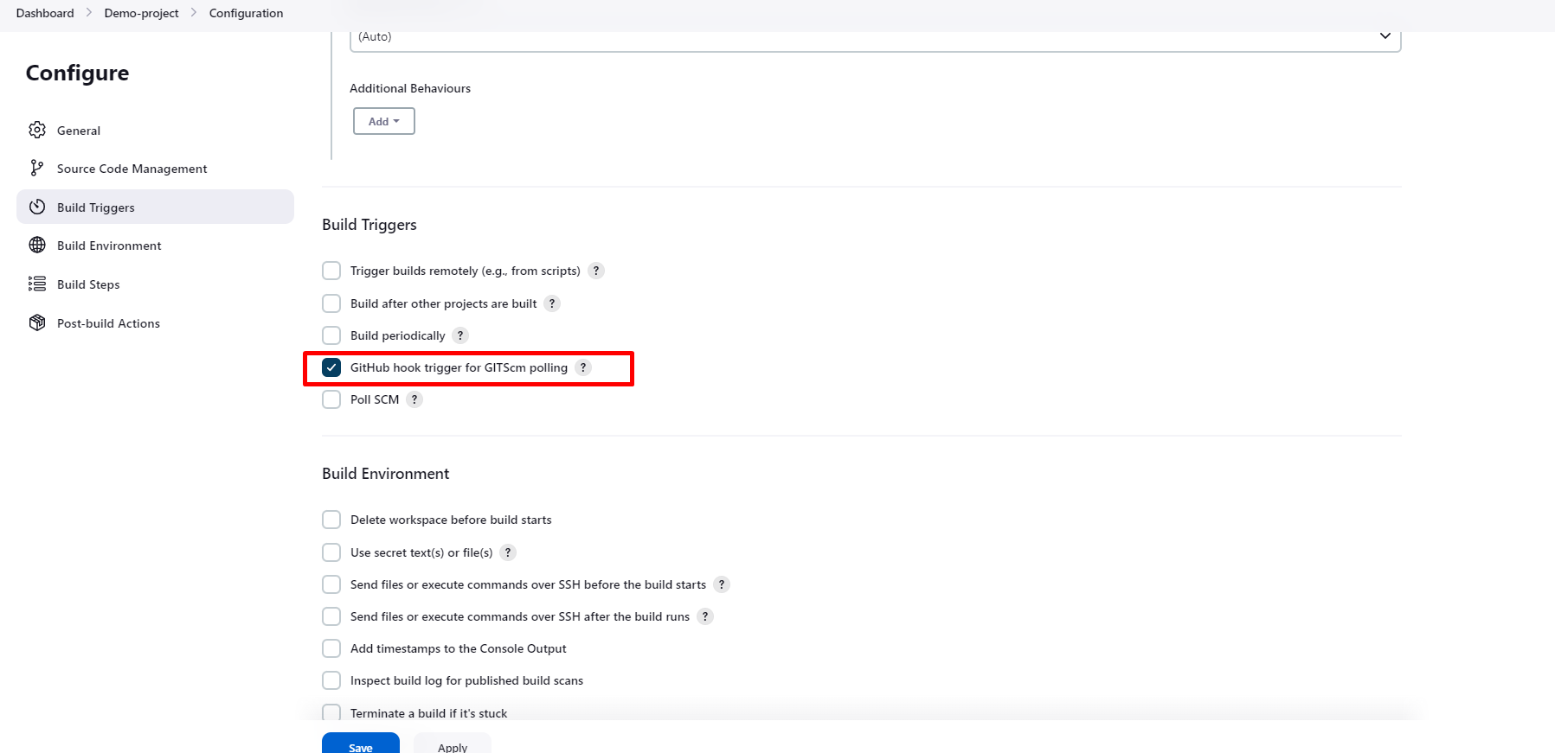

Then go to settings in GitHub .

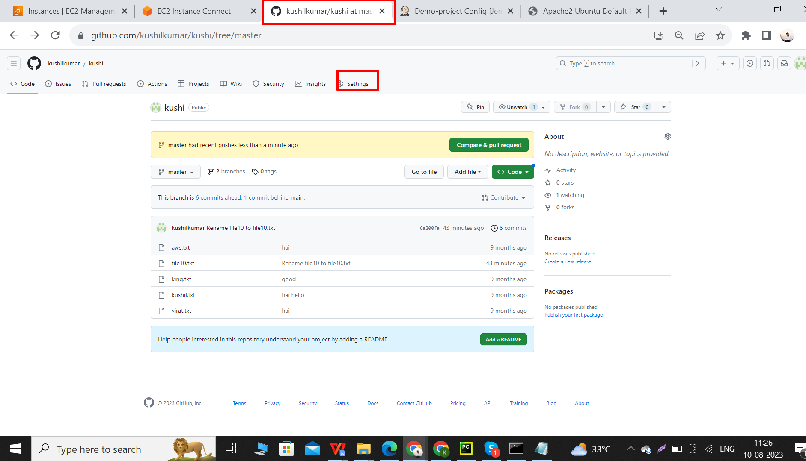

Then select webhooks and click on add webhooks.

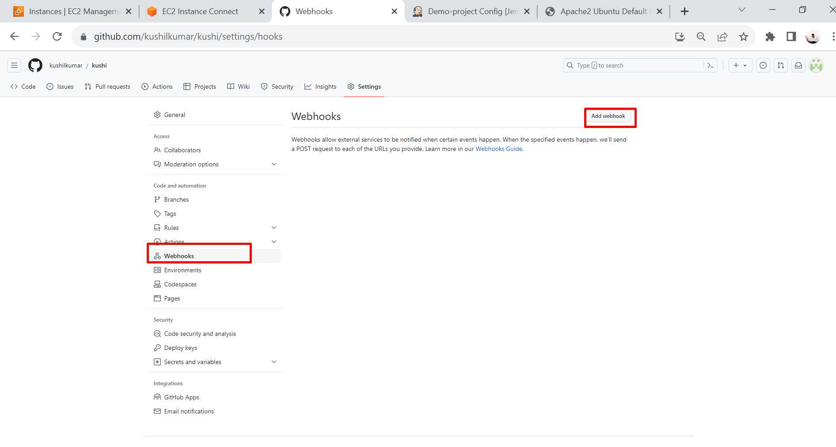

Then copy the Jenkins IP like https//15.207.100.131:8080.

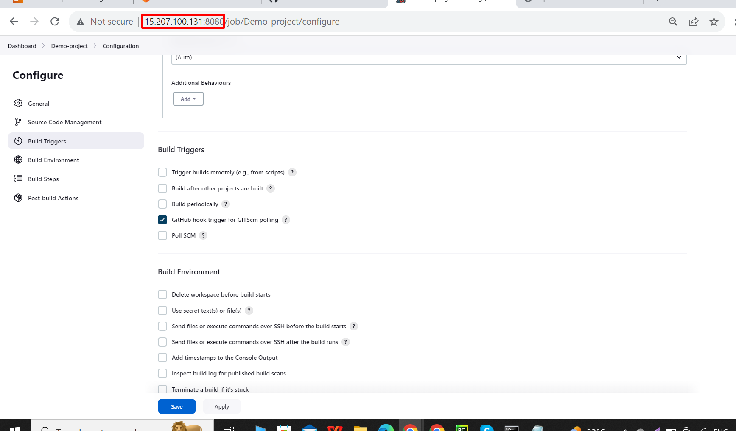

Next paste that jenkins url in the webhooks payload URl and click on add webhooks.

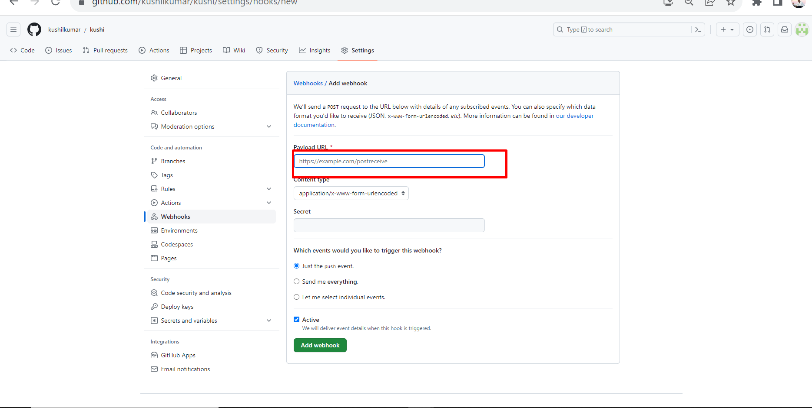

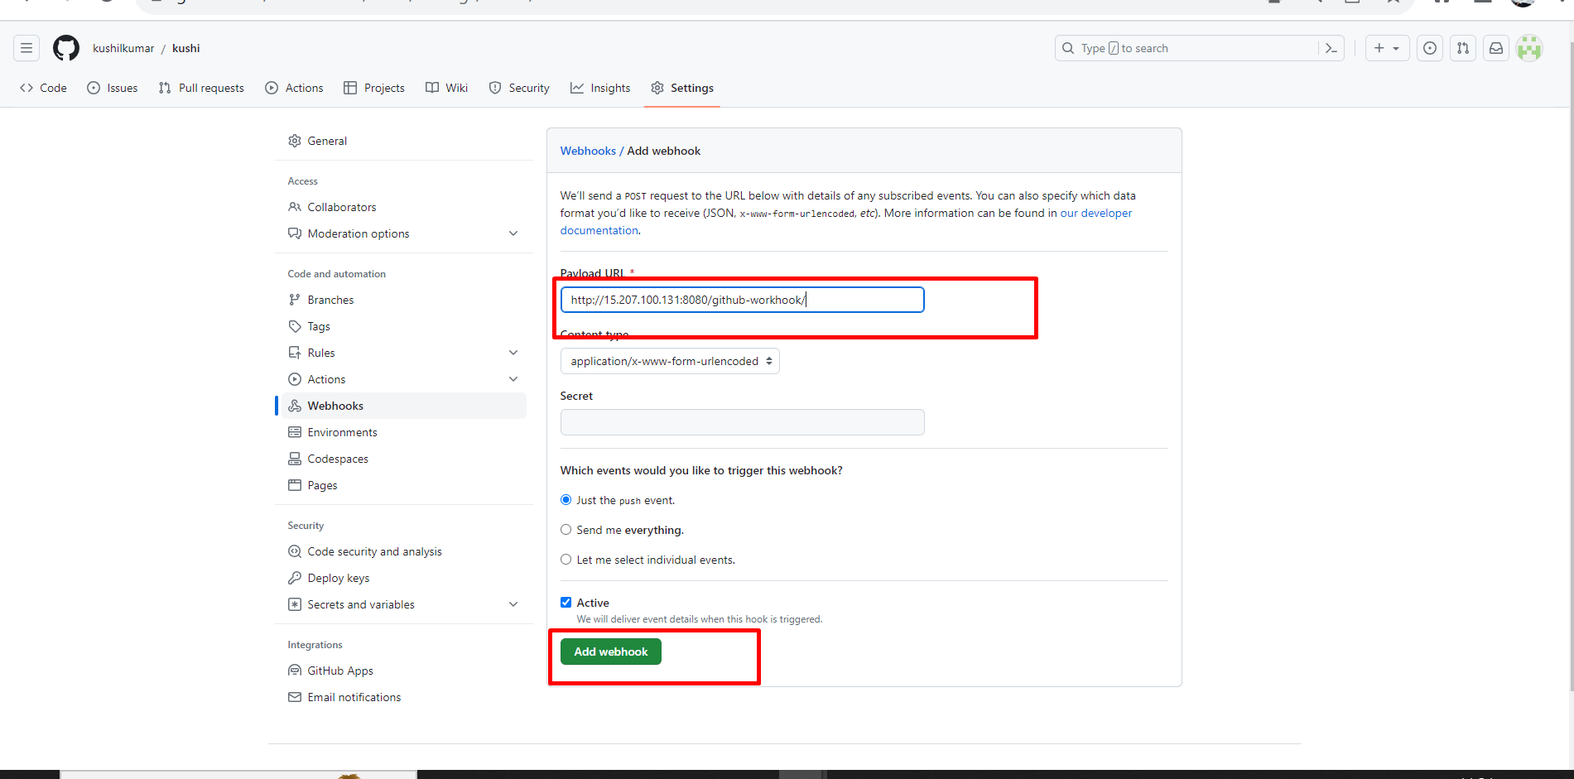

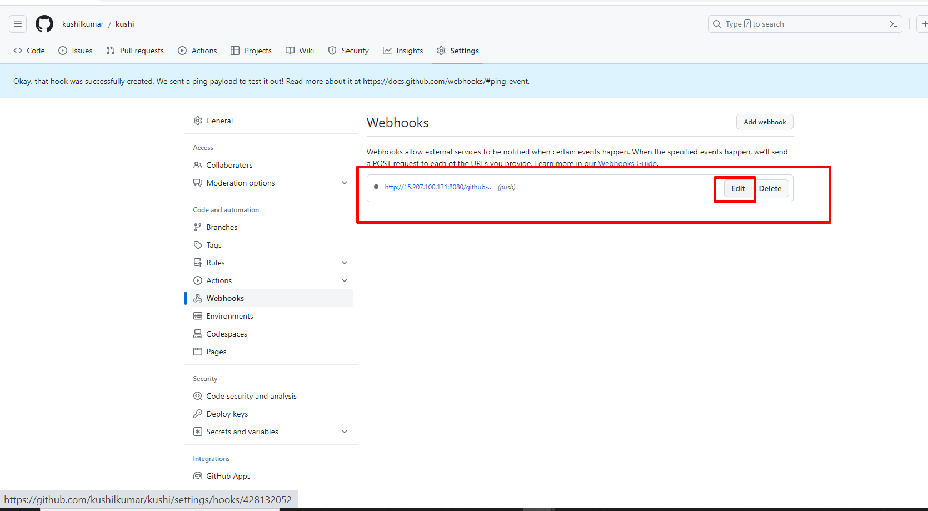

Here I do one mistake is I enter webbook, so I corrected that. **Note**:-webbook changed to webhooks.

Next click update webhooks.

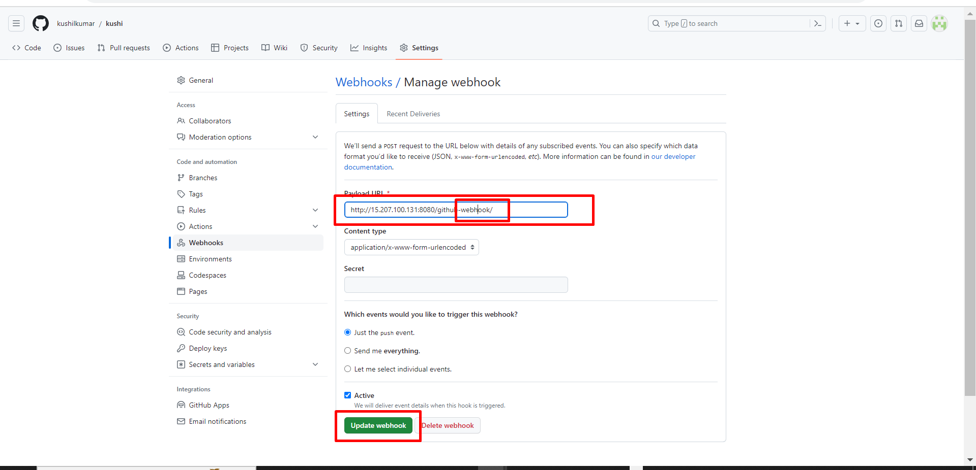

Updated successfully.

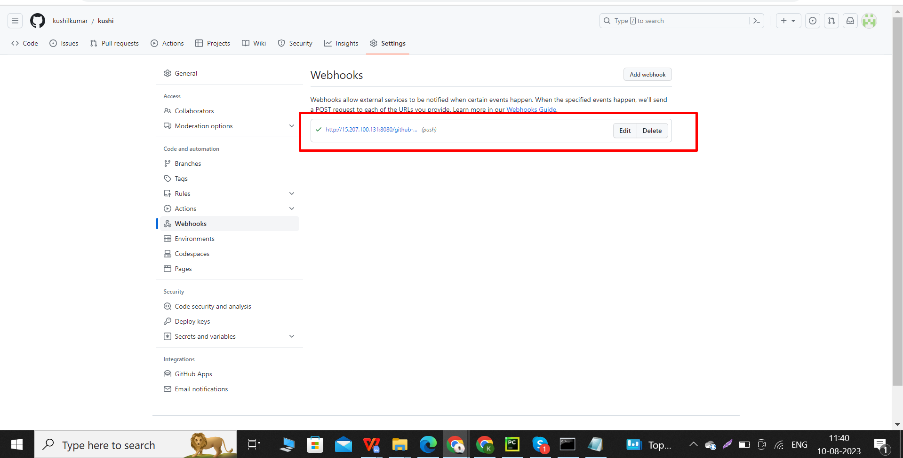

Next go to built environment in configure then select send files or execute commands over SSH after the build runs.

Next follow given process.

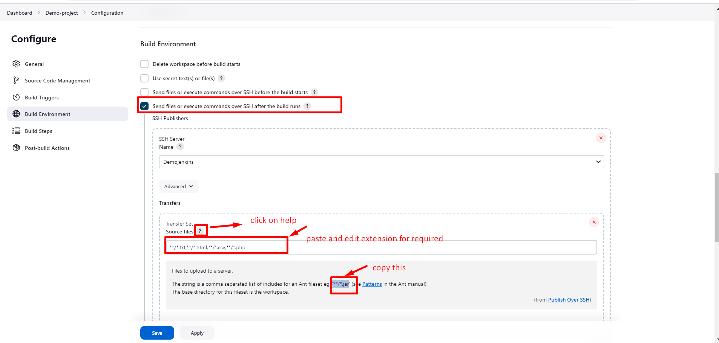

We already gave a remote directory path in this Jenkins so we enter “ / “ on that.

**Note**:- remote directory path = /var/www/html/.

Next click on apply and save.

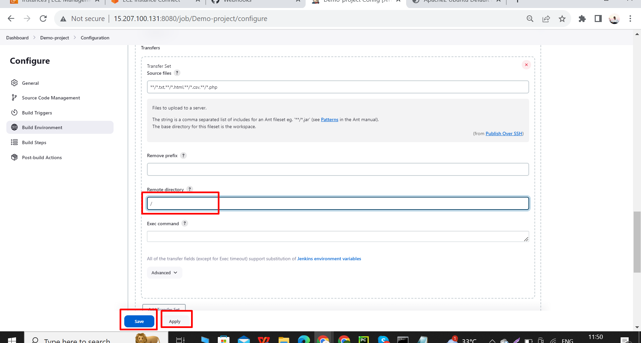

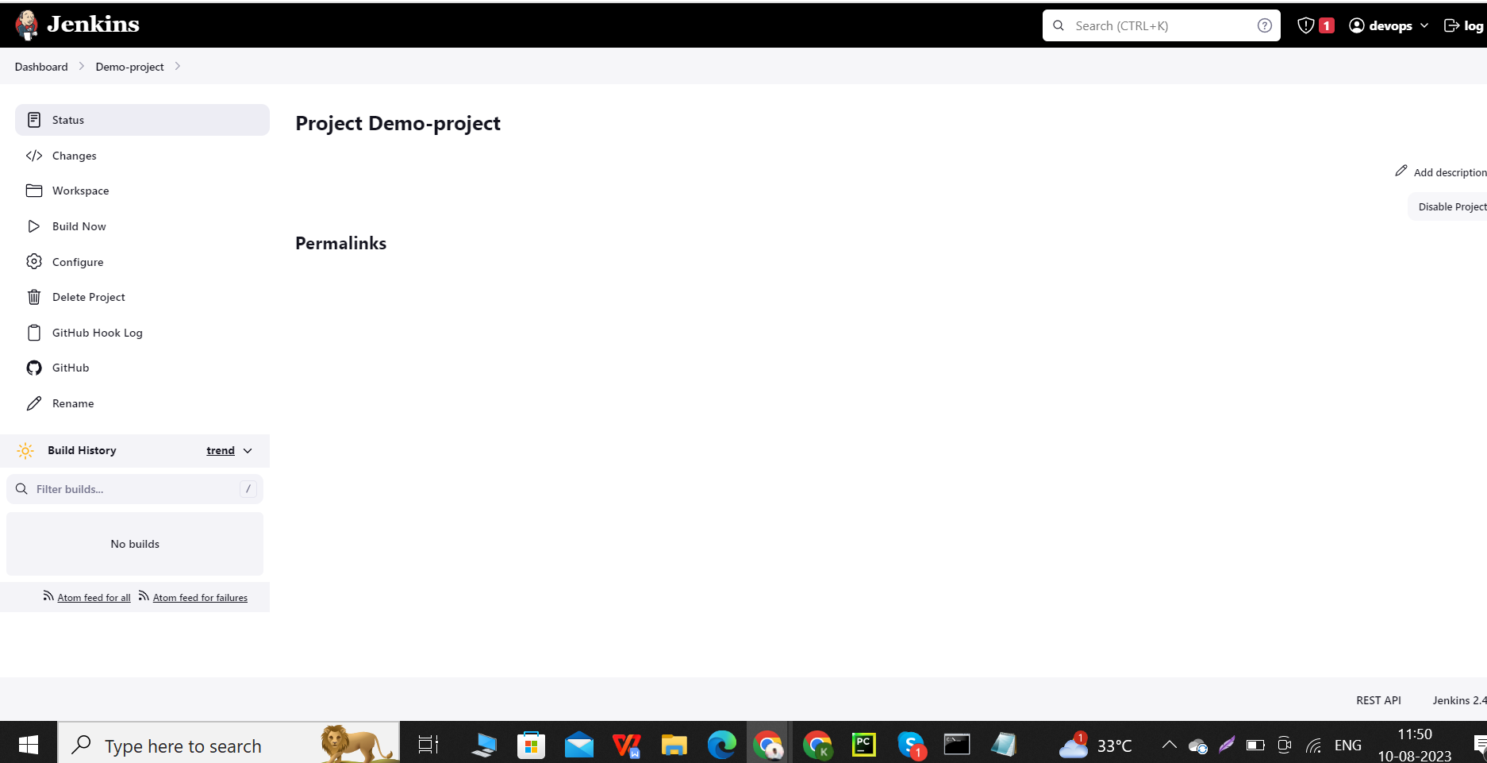

**Before we built code we do allow permission for that html path**

Follow given process.

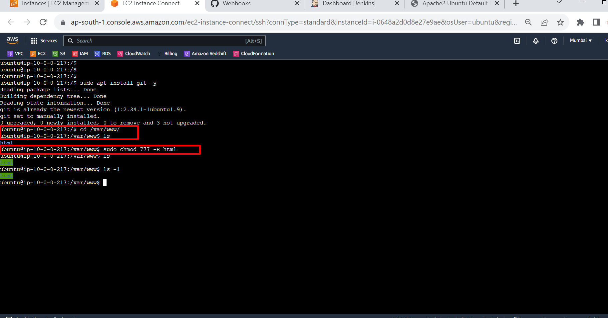

Next we click on build now.

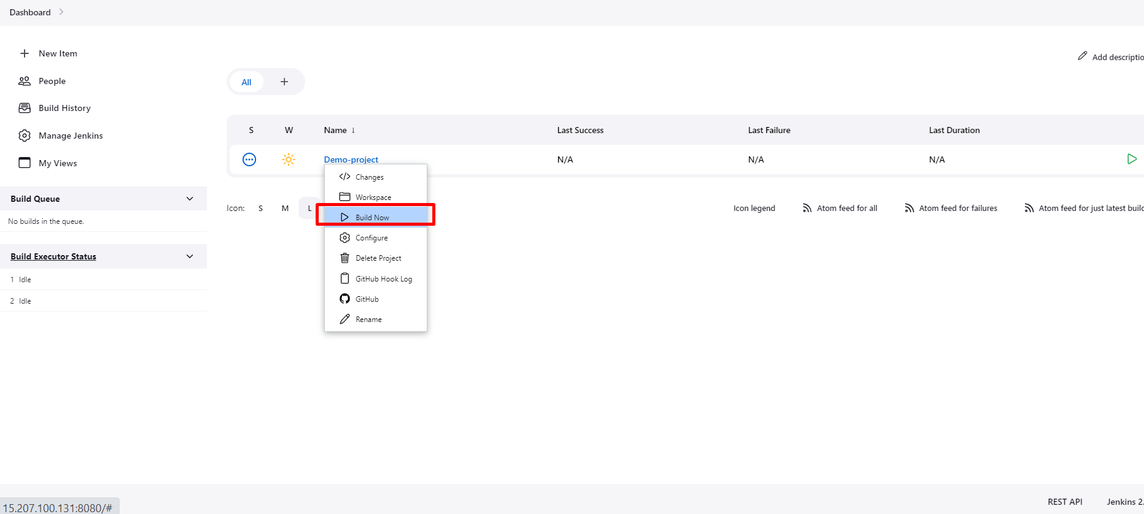

We successfully create a project.

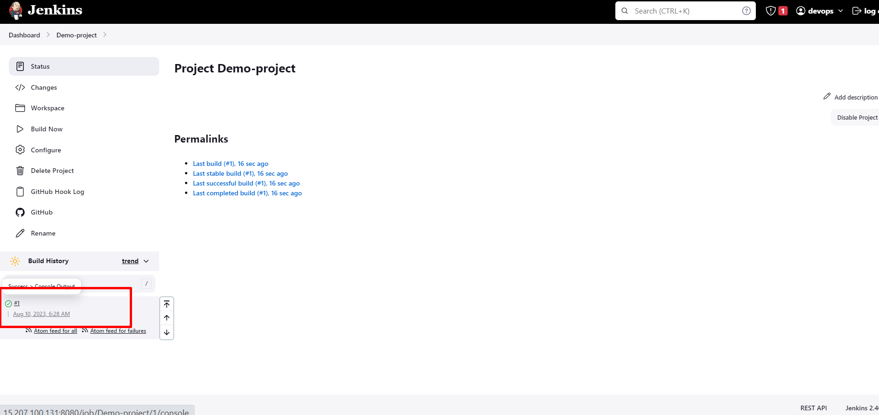

We successfully transferred files from GitHub to Ubuntu server.

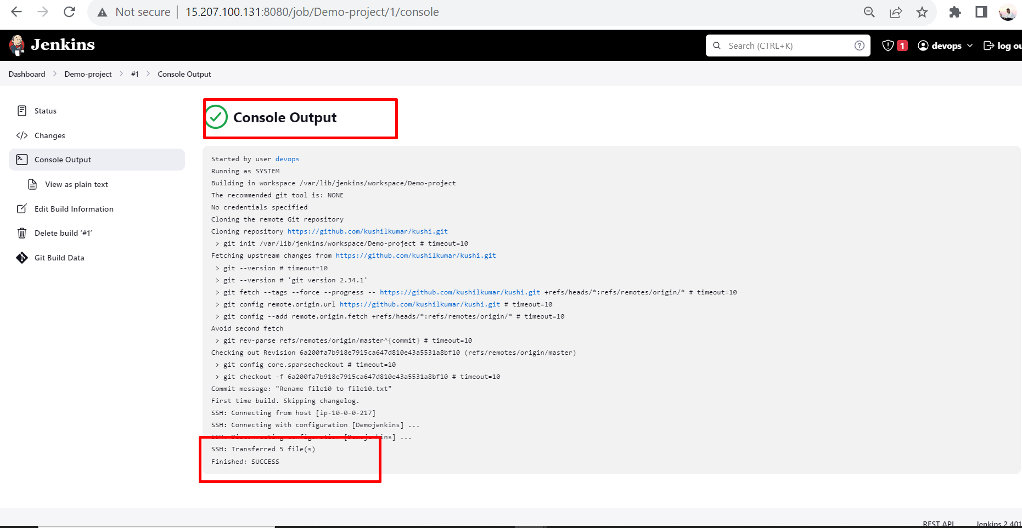

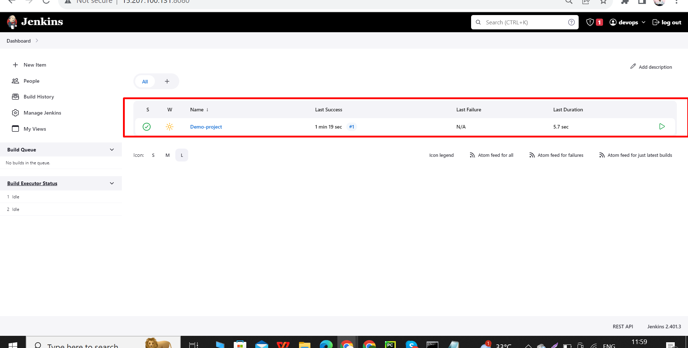

Here we see the output.

